Microsoft® Internet Explorer 5
Corporate Deployment Guide

March 1999



© Copyright 1999 Microsoft Corp. All rights reserved.
The information contained in this document represents the current view of Microsoft Corporation on the issues discussed as of the date of publication. Because Microsoft must respond to changing market conditions, it should not be interpreted as a commitment on the part of Microsoft, and Microsoft cannot guarantee the accuracy of any information presented after the date of publication.
This document is for information purposes only. MICROSOFT MAKES NO WARRANTIES, EXPRESS OR IMPLIED, IN THIS DOCUMENT.
The example companies, organizations, products, people, and events depicted herein are fictitious. No association with any real company, organization, product, person, or event is intended or should be inferred.
Microsoft, Windows, Active Channel, Active Desktop , ActiveX, Authenticode, Jscript, MS-DOS, MSN, NetMeeting, Outlook, Visual Basic, the Windows logo, Windows NT, and Win32 are either registered trademarks or trademarks of Microsoft Corporation in the United States and/or other countries.
Other product and company names mentioned herein may be the trademarks of their respective owners.
Microsoft Corp. • One Microsoft Way • Redmond, WA 98052-6399 • USA

This document provides corporate administrators with a comprehensive guide to deploying custom installations of the Microsoft Internet Explorer 5 browser using the Internet Explorer Administration Kit 5, one of the fastest and most powerful ways to deliver the benefits of Internet Explorer 5 to end-users. This guide will help administrators with the following tasks:
Abstract
- Creating custom packages using the Internet Explorer Administration Kit 5, including best practices advice.
- Preparing for deployment, including how to create a successful pilot rollout.
- Using post-deployment tools to centrally manage Internet Explorer 5 installations.
Internet Explorer 5, the latest major update to the award-winning Internet Explorer browsing technologies, is optimized to save users time on the activities they perform most often.
For the latest information on Microsoft Internet Explorer and the Internet Explorer Administration Kit, please visit http://www.microsoft.com/windows/ie/.

Table of Contents
Introduction 7
Getting Started 13
Step #1: Gathering Information 15
Step #2: Configuring Custom Packages 19
Stage 1: Gathering Information 21
Stage 2: Specifying Setup Parameters 29
Stage 3: Customizing Setup 37
Stage 4: Customizing the Browser 52
Stage 5: Customizing Components 75
Stage 6: Browser Distribution 89
Managing Users: Internet Explorer Administration Kit Profile Manager 93
Appendix B: Enabling Connections with the Connection Manager Administration Kit 99
Appendix C: Creating a Pilot Program 123
Appendix D: Automatic Connections 127
Appendix E: Using Microsoft Systems Management Server 129
Glossary of Terms 140

Introduction
As Web use increases and more companies take advantage of intranets and extranets, Web browsing technology becomes increasingly important. Most IT departments now look at browsers on the same strategic level as operating systems, productivity and line-of-business applications (which are often now Web-based). And the majority of companies now include browser as part of a user’s standard desktop.
Increasingly, many organizations prefer to deploy customized browsers, an efficiency that allows them to achieve the following benefits:
- Increased productivity. Administrators can customize browsers by pre-populating proxy settings, Favorites, security settings and digital certificates, helping users become more productive because they won’t spend time looking for required tools and resources. By deploying customized browsers, administrators can give users access to key intranet and extranet applications, and ensure that all browsers have the same functionality.
- Increased manageability and reliability. By creating custom packages, administrators can test components with key line-of-business applications to maximize reliability, and reduce costs for support, deployments, and upgrades. Administrators can centrally and dynamically manage a user’s desktop browser components. Upgrading e-mail clients, for example, can be achieved efficiently without upgrading other components.

Automated Deployment Options
To automate customized browser deployment, administrators have the following options:
- Disk image copying. Disk image copying, sometimes called “cloning,” is one of the fastest ways to set-up new desktops. Disk image copying means creating an image of a standard desktop and then copying that image onto new or existing systems. Custom browser settings are configured as part of the standard desktop image. Disk image copying is generally fast and cost effective because without any user interaction nearly every component can be configured, including the operating system, applications, and desktop customizations. However, disk image copying is not appropriate for every situation and environment. Images work only on identical or very similarly configured hardware. If upgrading an existing system, all user settings and data on existing systems must be stored in another location, such as on a server, because disk imaging overwrites any existing files on the system.
- Electronic Software Distribution. Electronic software distribution (ESD) uses specialized applications to install software on desktops across a network. Unlike other deployment methods, ESD is generally a component of more comprehensive enterprise management suites available from companies such as Hewlett Packard, Intel, Microsoft, and Tivoli. ESD often relies on the same installation scripts used to install the operating system, although some ESD solutions provide a more extensive graphical environment for creating these scripts and stronger integration with application setup languages. IT professionals also use ESD solutions to generate reports on the success and progress of deployments. Enterprise management suites enable better management of the deployment process, such as scheduling remote installations for better network bandwidth use. Ultimately, however, ESD is more complex than disk image copying. For example, building infrastructure for ESD is more time consuming than creating and copying images and some ESD solutions depend on the presence of hardware technologies.
- Internet Explorer Administration Kit. The Internet Explorer Administration Kit is a tool designed to enable administrators to create a hands-free customized installation of Microsoft Internet Explorer 5. Using the Internet Explorer Administration Kit, administrators can:
- Tailor browsers and other Internet components to fit an organization's needs, for example, by customizing the Links bar and Favorites lists to promote the organization or provide helpful information.
- Configure settings before an installation, so administrators don't need to set options on each computer.
- Customize Setup so that it requires less intervention and installs custom programs.
- Manage which settings users can change, to ensure that security, connection, and other important settings adhere to corporate standards.
The Internet Explorer Administration Kit is the deployment method described in this paper. For more information on other automated deployment methods, please visit www.microsoft.com/windows/ie.

Internet Explorer Administration Kit Components
The Internet Explorer Administration Kit 5 consists of the following primary components:
- Internet Explorer Customization Wizard. The Customization wizard provides five stages of step-by-step screens that help you create customized Internet Explorer packages.
- Internet Explorer Administration Kit Profile Manager. The Profile Manager lets you automatically change your users' settings and restrictions after Internet Explorer has been installed.
- Connection Manager Administration Kit. The Connection Manager Administration Kit (CMAK) is a wizard that guides you through customizing and configuring the Microsoft Connection Manager dialer. The CMAK creates a self-extracting executable file (.exe) that installs itself on your users' computers. Then when a user clicks the custom icon to connect to the Internet, the dialer dialog box that you created appears. You can build a custom profile into your Internet Explorer packages.
- Internet Explorer Administration Kit Toolkit. The Internet Explorer Administration Kit Toolkit contains helpful tools, programs, and sample files, such as the IExpress wizard, sample sign-up and add-on files, artwork, and other tools. The Toolkit contents are located in the Toolkit folder of the Internet Explorer Administration Kit program folder.
- Internet Explorer Administration Kit Help. To get quick access to information you need, use the Index tab, the Contents tab, or the Search tab. You can print a single topic, all topics at once, or a group of related topics.

Key Internet Explorer Administration Kit Capabilities
Internet Explorer Administration Kit 5 provides many enhanced and new capabilities over previous Internet Explorer Administration Kit versions. The best way to become familiar with the features is to go through the Internet Explorer Administration Kit in demonstration mode and explore each of the wizard pages. The following are some of the highlights and key capabilities.

Internet Explorer 5 Distribution Options
- Platform Options – Administrators can distribute customizations to clients running Windows NT® (3.51 or greater), Windows® 95, Windows 98, Windows 3.11, and Windows for Workgroups, Solaris 2.5 and greater, HP-UX 10.2 or greater (Mac version of Internet Explorer Administration Kit is scheduled to be available separately).
- Distribution Media Options – Administrations can choose Web download, CD-ROM, multiple floppy disk or LAN deployment. Single-disk branding, a new feature in Internet Explorer 5, enables configuration of Internet Explorer settings without installing code on the client machine. (Note: Single-disk branding will be available only systems running Internet Explorer 4.01 SP1 or greater.)
- Custom Components and Add-on Applications – Up to ten custom components, self-extracting executables (.exe), or cabinet files (.cab) can be installed along with Internet Explorer 5, saving administrators time and effort during distribution, and reducing interruptions in user productivity. Custom components can include in-house applications, shareware, or other programs that administrators want to distribute.
- Pre-Install Components or Applications – Custom components can be installed before installing the Internet Explorer 5 browser. This is particularly useful for utilities that prepare machines for a browser installation. For example, registry-cleaning utilities can be run before installing Internet Explorer so that browser-created registry keys are affected.
- Controlled User Interaction – Corporate administrators can set the following install options for Internet Explorer 5: Interactive, Hands-free, and Completely Silent. Interactive installation allows users to customize components during installation; Hands-free installation displays error and progress messages but doesn't prompt users for information; and Completely Silent installation is hidden from the user. This allows administrators to select the most appropriate level of user involvement for each installation.
- Installation Options – Each installation package can be customized with up to ten installation options, each of which includes a specific set of components. Internet Explorer Administration Kit 5 includes minimum, standard, and full installation types, which administrators can keep, remove, or customize. Installation options allow an administrator to create and distribute a single package that can be tailored for multiple groups of users.
- Installation Directory – The Internet Explorer 5 installation directory can be customized, and administrators can prevent users from changing this location. Enforcing a standard location for Internet Explorer 5 can improve administration and troubleshooting, and improve the accuracy of versioning, metering, and inventory software.
- Improved Web Deployment – Web installations can be configured to use up to ten download sites: If a connectivity problem occurs, the installation can switch to another site. Internet Explorer 5 setup can also resume an interrupted download. This helps ensure that users experience as smooth an installation process as possible.
- Versioning – Internet Explorer Administration Kit 5 automatically versions every package, and it can be configured to allow or prevent overwriting of older versions onto newer versions. Individual Internet Explorer 5 components are also versioned and can be individually updated with an installation package without having to reinstall all components. Versioning enables efficient updates to packages and helps ensure standardization across an organization.
- Optimize for Web Download – Internet Explorer 5 Setup can detect Internet Explorer components that are already on a user’s system. Existing components are not downloaded again. For example, dynamic HTML data binding will not be reinstalled on a user’s system, even if it is included in the installation package. Web download optimization saves bandwidth usage and time and is particularly helpful for users downloading via slow connections. To create a uniformly homogenous environment, web download optimization can be disabled so that each system has precisely the same version of each component.
- Automatic Installation – Administrators can include components in a distribution that won’t be installed until users require them. For example, if Internet Explorer 5 detects that a user needs Microsoft Virtual Machine, Internet Explorer will automatically find the distribution point (a LAN share, for example) and install the necessary components. This helps minimize the time and disk space wasted by installing components a user never needs.
- Automatic Digital Signing – Internet Explorer 5 packages can be digitally signed for distribution. By including a digital signature, administrators provide users with a guarantee that the package hasn’t been changed and the source is known

Browser Customization Options
- Browser Title – The browser title bar can be appended to read "Microsoft Internet Explorer provided by Company X…" This promotes corporate or brand awareness when using Internet Explorer 5.
- Browser Toolbars – Custom browser toolbars can be added to launch applications or run scripts. The default toolbar buttons can each be disabled as well. This enables administrators to provide precisely the set of tools each user needs.
- Browser Logos – The static and animated bitmaps in the top right-hand corner of the browser window can be customized. This option was previously available only to customers with special Microsoft Licensing Agreements. This is one of the most visible areas of Internet Explorer for branding with a custom logo.
- Favorites / Channels – Channels are now better integrated with Favorites, and both sets can be pre-populated by the administrator. The Favorites list, which can be populated and organized with up to 200 links, can be ordered, and Favorites can be placed either at the top or bottom of the list. Administrators can use the lists to distribute important company links, and users will find the lists easier to organize and manage.
- Welcome Page – The first time the browser is started, a special page with introductory information can be displayed. This URL can be either the Microsoft default or a customized page, or administrators can opt for no start page. The “Welcome to Internet Explorer” dialog box that ran automatically in Version 4 has been removed. Companies can use this welcome page to communicate key information about Internet Explorer 5, including company browsing policies, support services information, and other company-specific messages.
- Per Connection Settings – Internet Explorer 5 includes improved logic for determining connection status. Unless locked out by the administrator, users can edit connection settings (including proxy settings) on a per-connection basis, such as setting separate configurations for accessing an ISP and the corporate network. Internet Explorer 5 will detect which connection is being used and apply appropriate connection settings automatically. Administrators can import these connection settings from an existing machine to users’ machines so that when users click on the Internet Explorer icon, it will automatically dial using the correct connection settings. This greatly simplifies creation of auto-dial settings for administrators and minimizes proxy-setting problems for users.
- Proxy – Proxy servers and proxy exceptions can all be pre-populated. These settings can be configured on a per-connection basis, and they can be imported during package creation. This makes it easier for administrators to create packages, and makes connecting much easier for users with multiple connection settings.
- Certificates – Certification Authorities (CAs) and Authenticode settings can all be pre-populated. By creating a list of pre-approved CAs, administrators can prevent users from installing software from non-approved vendors.
- Security Zones – Security Zones enable administrators to set appropriate levels of security based on how a Web page is accessed (Internet, Local Intranet, Trusted Sites, Restricted Sites). All security zone settings can be customized, and administrators can prevent users from being able to change these settings. The Local Machine zone (My Computer) can also be customized separately, giving administrators more control over what users can view.
- Content Ratings – Content Ratings can be adjusted, password protected, and included in the package. This helps administrators enforce Internet use policies consistently throughout an organization. Administrators can also create, enforce, and dynamically manage an approved/disapproved site list.
- Update Check Page – The browser can be configured to present a custom startup page at regular intervals. This enables companies to ensure that a Web page is displayed on an Internet Explorer workstation at least once.
- Toolbar Background Bitmap – The browser toolbar background bitmap, or "watermark," can be customized. This is another component of browser branding, offering the benefits of higher visibility for a company or brand, both internally and externally.

Other Key Capabilities
- Administrator-Approved ActiveX® Controls List – Administrators can specify certain controls to run while locking out all others. This helps the administrator maintain a consistent version of Internet Explorer code throughout an organization, reducing administrative overhead and troubleshooting issues. The approved set of ActiveX controls can be enabled and administered dynamically by using the System Policies and Restrictions features in the Internet Explorer Administration Kit Profile Manager.
- CMAK Ships with Internet Explorer Administration Kit – CMAK (Connection Manager Administration Kit) is shipped and simultaneously installed with the Internet Explorer Administration Kit (all part of Internet Explorer Administration Kit 5.exe). The CMAK is also available with the Customization wizard and can automatically integrate a Connection Manager profile into the Internet Explorer package.
- Feature Selection – The Internet Explorer Customization wizard can be customized to only show the sets of features necessary for that particular package. For example, if a corporate administrator only cares about customizing Favorites, then all other non-mandatory screens will be hidden to save time and reduce complexity.
- Single-Disk Branding – For systems running Internet Explorer 4.01 SP1 or greater, administrators can use the Customization wizard to create a single floppy disk that simply brands the system with custom text and logo information, and then sets up connections if necessary. This provides methods a simple way to add branding information and set up settings for existing Internet Explorer 5 users.
- Automatic Configuration – Browser and component settings, as well as system policies and restrictions, can be updated automatically at regular intervals or every time the browser is started. This feature provides an easy way to configure and distribute not only Internet Explorer 5 settings but also Windows Profile settings to groups of users throughout an enterprise.
- Outlook® Express – Outlook Express is available with Internet Explorer 5, and Internet Explorer Administration Kit 5 can be used to pre-populate mail and news server settings, as well as a welcome email message and customized InfoPane. Additional Outlook Express customizations include newsgroup pre-population, message rules, and views options. This makes it easier for administrators to set up new machines or users with mail and ensure a standard mail client throughout a corporation without making users perform setup and configuration.
- HTML Help – All of the Internet Explorer Administration Kit 5 documentation uses the HTML Help engine, the same Help engine used in Internet Explorer 5 and Windows 98. HTML Help is referenced and hyperlinked to improve access to technical information in the Help file.
- Improved UI – The Internet Explorer Administration Kit 5 Customization wizard has an easier-to-use, more attractive, and better-organized user interface, making deployment much more straightforward and less time-consuming for administrators.
- Office Custom Installation Wizard (OCIW) Mode – For administrators interested in deploying Internet Explorer 5 at the same time as Office 2000, the Internet Explorer Administration Kit is featured as an Office Toolkit and is easily accessible via the OCIW.

Enhancement from Previous Versions
For administrators who are familiar with previous versions of the Internet Explorer Administration Kit, the following are some of the key enhancements:
- Smaller setup footprint and modular features. Internet Explorer is smaller and more modular. Administrators have more control over which features are installed and whether users can customize setup options.
- Install only the features users need. Administrators can install only the Internet Explorer 5 features users will need, and enable users to install new features as necessary with the Automatic Install feature. Through System Policies and Settings, administrators can control whether this feature is enabled.
- View only the Internet Explorer Customization wizard screens that apply to you. In the Customization wizard, administrators can specify only the features they want to customize. This is especially helpful to specify only a few custom settings.
- Improved digital certificate support. The Internet Explorer Administration Kit wizard can sign custom files and programs automatically. Signing files is necessary for distributing files over the Internet or when administrators don't want to specifically configure intranet settings.
- Batch text setup file. The Internet Explorer Administration Kit enables administrators to customize setup, but administrators can further control setup by using a batch text file. Administrators can include the batch file in a custom Internet Explorer Administration Kit package.
- Enhanced Automatic Version Synchronization (AVS). When you download updated program versions, administrators don't need to download setup (.cab) files that haven't changed. This saves download time. The version number and disk space needed for each component are also displayed in the AVS interface.
- Custom browser toolbar buttons. Administrators can customize the browser toolbar by specifying custom buttons to run scripts or executable files.
- Automatic Install. Internet Explorer enables users to easily install features that were not initially installed with the package.
- Update notification page. Administrators can provide information about updated programs, files, or company news at intervals with a standard .htm page.
- Installation into a custom directory. Administrators are now prompted to choose an installation directory, so previous versions of the Internet Explorer Administration Kit do not have to be overwritten. Administrators can also determine whether or not users can change their installation location.

Getting Started
Creating and deploying custom Internet Explorer 5 packages follows the same process as upgrading or changing any desktop component. Microsoft recommends the following steps in a properly planned deployment:
- Gather information and make decisions. Use the Custom Build Checklists in this document to gather necessary information and files. The Checklist also helps administrators make decisions about deployment, such as distribution type and components to include.
- Learn how to use the Internet Explorer Administration Kit. Build a pilot deployment package using the Internet Explorer Administration Kit. Complete instructions and information on the Internet Explorer Administration Kit are in Step #2, “Configuring Custom Packages with the Internet Explorer Administration Kit Customization Wizard.”
- Trial Deployment #1. First, test the pilot deployment in a lab on non-production machines. Instructions and guidelines on how to conduct a test lab are included in Appendix C. The installation process and browser configuration should be tested for all platforms and installation media types.
- Trial Deployment #2. After initial deployment, update and version the deployment package with any changes incorporated from the test lab. Test the final deployment in a lab on non-production machines. It is not safe to assume that changes, no matter how small, will have no effect on the deployment. Two hours of testing in the lab can save two weeks of trying to fix a bad deployment.
- Final Deployment. Once the final version of the package is tested and approved, deploy it to the organization.
The creation and deployment of this (and any other) software package is iterative; this Plan→Develop→Test procedure could go through a single cycle⎯or many cycles⎯before the package is ready for deployment.

Step #1: Gathering Information
The following checklist can be used to gather the necessary information in advance of using the Internet Explorer Administration Kit 5. An asterisk (*) denotes required information. More information about specific components can be found in the Glossary section.

Important Decisions
* Company Name: * Product Keycode:
* Platform: Windows 9x/Windows NT Windows 3.x UNIX
* Type of Distribution: Download CD-ROM Flat (LAN) Multiple Floppy
* User Interaction: Interactive Hands-Free Silent
To add additional third-party components or programs to the Internet Explorer package, fill out the Custom Component section at the end of the checklist.

Title Bar Customizations
Information is used to customize installation screens and the browser interface.
CD Autorun Screen Titlebar Text:
Setup Wizard Titlebar Text:
Browser Titlebar Text:
(i.e., Microsoft Internet Explorer provided by “ACME”)

Files to Collect
Information will be used to customize users’ desktops, but is not necessary to complete a deployment. This feature is primarily for Internet Service Providers (ISPs) who want to extend custom branding to Internet Explorer 5.
Setup Wizard Top Banner (496x96 pixels) Setup Wizard Left Bitmap (162x312 pixels)
Browser Toolbar Background Bitmap Large Animated Browser Logo (38x38 pixels)
Small Animated Browser Logo (22x22 pixels) Large Static Browser Logo (38x38 pixels)
Small Static Browser Logo (22x22 pixels) CD Autorun Bitmap Path (540x347 pixels)
CD Autorun “More Information” text file CD Autorun Kiosk Mode Startup HTML file

URLs to Collect
These URLs will become part of a user’s desktop.
Home Page URL:
Search Pane URL:
On-Line Support Page URL:
Favorite URLs: (1)
(Up to 200) (2)
(3)
Product Update Page:
Custom Welcome Page:

Automatic Connection
Pre-configuring dial-up settings will help users connect more easily.
Name of Dial-Up Entry:
Phone Number
Use Proxy Server? Yes No
If Yes, Proxy Settings: Address: Port:

Outlook Express
Incoming Mail Server Address:
Outgoing Mail Server Address:
News Server Address:
InfoPane: (URL or Local File)
URL Path:
Local File HTML Path:
Local File Image Path:
Custom HTML Welcome Message:
HTML Path:
Sender Address:
Reply-To Address:

LDAP Address Server
Service Name:
Server Name:
Service Web Site:
Search Base:
Service Bitmap Path:

Digital Signatures
Certification Authorities (CAs) issue digital certificates verifying the electronic identity of individuals and organizations. If the administrator has a publisher certificate from one of the CAs, the customer package can be automatically signed.
Company Name on Certificate:
Software Publishing Certificates (.spc) file:
Private Key (.pvk) file:
Description Text:
More Information URL:

Certificate Customization
Administrators can add a root certificate to their customized Internet Explorer Administration Kit package by typing the URL into the new root certificate path box. The root certificate provides a level of trust that certificates lower in the hierarchy can inherit. Each certificate is inspected for a parent certificate until it reaches the root certificate.
New Root Certificate Path:

Channels
Administrators can customize the Channels in their package. Fill out the following items for each desired channel:
Channel Title:
Channel Definition file on Web Server URL:
Channel Definition file Path:
Narrow Channel Image Path:
Channel Icon Path:

User Agent String
Some companies track site statistics, such as how many times their content is accessed and by which types of Web browsers. User Agent Strings help identify the browser type.
User Agent String:

Custom Components
Up to ten custom components can be added, which customers may install along with Microsoft Internet Explorer and the other Microsoft components selected by the administrator. These components may be provided in the form of a compressed cabinet (.CAB) file or a self-extracting executable (.exe) if applicable. If a .cab file is specified, the run command must also be specified.
Component:
Location:
Command:
Parameter:
Uninstall Key:
GUID:
Version:

*Web Distribution
Download Site Name (i.e., Primary Download Site):
Download Site URL (i.e., http://www.acmecorp.com/ie5):
Site Region (i.e., North America):
Local Path for Download Files (i.e., c:\wwwroot\ie5):

Step #2: Configuring Custom Packages
Use the Internet Explorer Administration Kit Customization wizard to create custom packages that install customized versions of Internet Explorer for users. Administrators should allow roughly one hour to configure the first package from start to finish. It’s best to do this in one session; otherwise, some options may have to be re-specified. The checklists in Appendices A and B help administrators quickly gather the required information. Once a package is configured, each subsequent package will require less time because some of the values specified for a previous package can be reused.
The following sections display all of the wizard pages in Internet Explorer Administration Kit 5. Each page is followed by a table that describes the features and options available on that wizard page. Depending on the administrator's choices, some screens described in this document may not appear.
Welcome Page
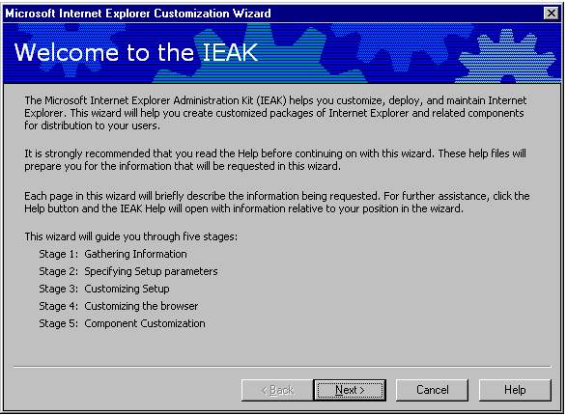
The Welcome Page is informational. Navigating through the Customization Wizard is the same as navigating through most wizards.

Action | Click
Display any previous page. May have to retype some of the values entered. | Back
Accept the values on the current page and move to next page. | Next
Exit this package. | Cancel
Need more information about using a page or specific feature. | Help

Stage 1: Gathering Information
In this stage of the Internet Explorer Customization wizard, corporate administrators are prompted for the following information:
- Your company name and ten-digit customization code. The customization code was included with other kit information you received from Microsoft.
- Your role based on your license agreement. You must specify whether you are a content provider or developer, service provider, or corporate administrator.
- The platform for which you will build your Internet Explorer package.
- The file locations for creating your customized browser package.
- The language of the browser package you are creating. You must run the Customization wizard for each international version you want to create.
- The distribution media you plan to use, such as CD-ROM or multiple floppy disks.
- The features you plan to customize. For example, if you are making only minor modifications to the browser, you won't need to view all of the Internet Explorer Administration Kit wizard screens.
Note: The Customization wizard will not work correctly if Internet Explorer 5 is not installed.

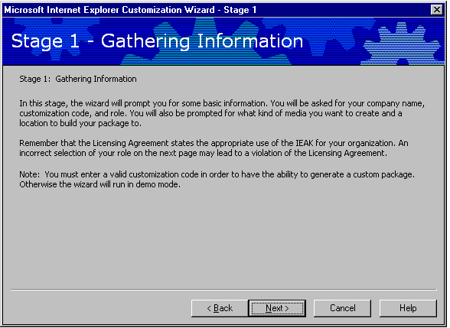

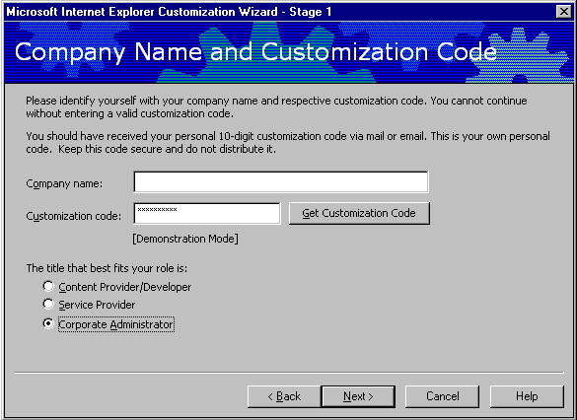
Company Name and Customization Code

Option | Explanation
Company name | Type the administrator’s company name. This information is put in the Registry for identification. This is not the name that will appear in the title bar of the browser. You will set this option later in the Internet Explorer Customization wizard.
Customization code | This customization code is required for creating distribution media (or you can run through in demonstration mode only); you cannot run the wizard without it. Keep this code safe and do not distribute it. You should have received your customization code via mail or e-mail after you registered. You must register for a license to redistribute Internet Explorer and related products. If you have lost your customization code, see the Internet Explorer Administration Kit Web site for further instructions.
The title that best fits your role | Because the customization code may not be specific to the administrator’s role, the wizard selects Content Provider by default. Be sure to select Corporate Administrator to receive all the necessary wizard options.

Platform Options
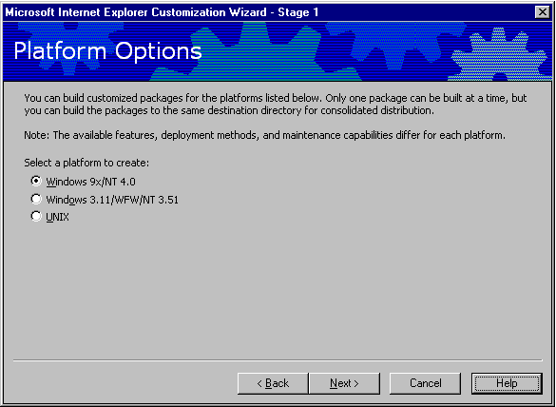
You can build customized Internet Explorer packages for the following operating systems:
- 32-bit versions of the browser run on these operating systems: Windows 95, Windows 98, Windows NT 4.0.
- 16-bit versions of the browser run on these operating systems: Windows 3.1, Windows for Workgroups 3.11, Windows NT 3.51 (Although Windows NT 3.51 is a 32-bit operating system, it runs the 16-bit version of the browser).
- UNIX versions of the browser run on these operating systems: Solaris 2.5 and greater, HP-UX 10.2 or greater.
To build an Internet Explorer Administration Kit package for a different operating system, you must run the Internet Explorer Customization wizard again.
Windows 16-bit versions of the browser: Some customization features, deployment methods, and maintenance practices are different for these Windows operating systems. For more information, see the Internet Explorer Resource Kit.
UNIX versions of the browser: Some customization features, deployment methods, and maintenance practices are different for the UNIX operating systems. For more information, see the Internet Explorer Resource Kit.

File Locations
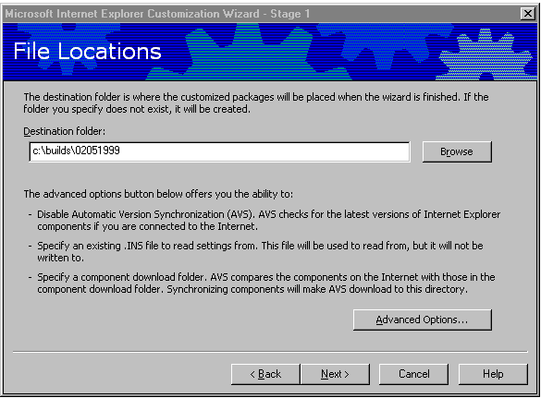
Option | Explanation
Destination folder | This is the location where the packages will be placed after the wizard is finished.

The destination folder is where customized packages will be placed when the wizard is finished. You can create the package on your hard disk and move it to an Internet or intranet server, or you can create it on a Web server.
Subfolders for each localized version are created in the destination folder you specify for each platform and media type.
If you are creating the package on your hard disk or network drive, the recommended destination is C:\Cie\Dist. If you are creating the package on a Web server that is running from your hard disk, the destination should be the path to the Web server.
For example, if you specify your destination folder as C:\Inetpub\Wwwroot\Cie\Dist, then the English language version for Windows NT 4.0 would be created in the C:\Inetpub\Wwwroot\Cie\Dist\Download\Win32\En folder.
Note, however, that all media versions (Web, CD, and LAN, for instance) of a package will get created in the subdirectory specified here.

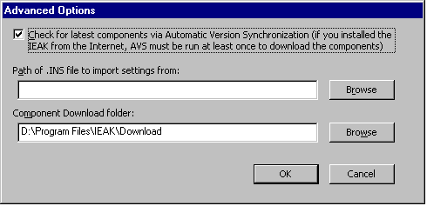
Advanced Options

Option | Explanation
Check for latest components via AVS | The Internet Explorer Administration Kit can check on the Internet for the latest versions of components when you create your Internet Explorer package. This feature can help you detect whether new versions have become available since the last time you ran the Internet Explorer Customization wizard. Automatic Version Synchronization (AVS) must be run at least once if the Internet Explorer Administration Kit was installed from the Internet.
Path of .ins files to import settings from | The Internet Explorer Administration Kit retains the most recently used settings of each separately saved build in the .ins subdirectory. Administrators can recover the settings from a previous .ins file by entering the path here.
Component Download folder | Administrators can specify a location for the downloaded components. The AVS feature automatically checks this folder to determine whether you have the latest components available. With AVS, you download only the components that have changed since the last time you downloaded them. It is recommended that you do not change this folder, so that you can keep the components synchronized. If this location is changed, then the Internet Explorer Administration Kit will need to resynchronize all components.

It is important that administrators understand versioning and version synchronization when setting a browser policy for an organization. Microsoft may periodically release a later version of the Internet Explorer 5 browser or its components, and the Internet Explorer Administration Kit can synchronize its downloaded components with the latest versions. However, once these components have been synchronized, there is no way to roll back to an earlier version when creating new packages. Administrators can access older versions of updated components in one of two ways:
- Check the “Change Component Download Folder” button when synchronizing components, and specify a new location for components. Selecting this option will require a complete resynchronization of all components because the Internet Explorer Administration Kit will not see any downloaded components in the new folder. This may be desirable if the integrity of an up-to-date component is unknown and a separate and newly downloaded version is desired.
- Make a copy of the c:\program files\ieak\download folder after downloading and synchronizing the production set of components,. This maintains a copy of older components in case an updated component needs to be rolled back. When synchronizing, only the new versions of components will be updated.

Language Selection
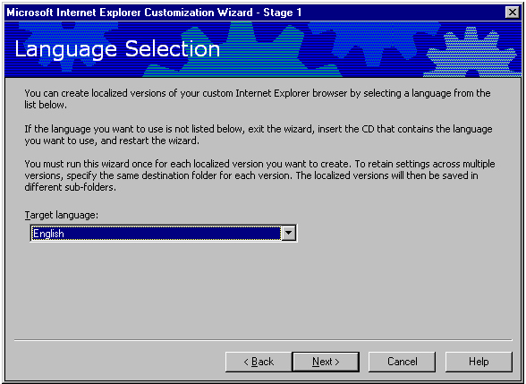
Choose the language you want from the Target language list. If the language you want to use is not listed, quit the wizard, insert the CD that contains the language you want to use, and then restart the wizard.
The language you choose determines how the following folders are structured:
- A subfolder for each localized version (for example, EN for English and DE for German) is created in the destination folder for your browser package. The destination folder is where the customized packages will be placed when the wizard is finished.
For example, if you specify that your destination folder is C:\Cie\Build1\, your customized package that contains a downloadable English-language 32-bit version of Internet Explorer 5 will be created in this folder:
C:\Cie\Build1\Download\Win32\En
If your users install the Windows Desktop Update, the language must match the language of their operating system. This limitation does not apply to the browser. If users attempt to install the browser and shell in a different language, only the browser will be installed.
You must run this wizard once for each localized version you want to create. To retain settings across multiple versions, specify the same destination folder for each version. The localized versions will then be saved in different subfolders.
Media Selection
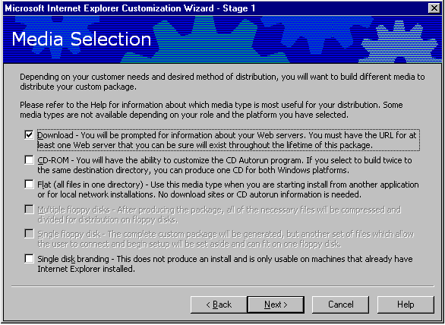
On this screen, you determine which type of media you will use to distribute your package. Almost every package created will require 20MB to 60MB of storage in the location specified in the previous screen. The recommended installation types for Corporate Administrators are CD-ROM, Flat, and/or Web Download.

Option | Explanation
Download | Select this option to build a package for downloading over an intranet or the Internet. You can build your customized packages on your hard disk, and then move them to an Internet server or, if you're a corporate administrator, an intranet server. You can also build your packages directly on the server by specifying the server path as the target folder.
CD-ROM | When you create a version on CD-ROM, you can also specify Autorun information. This option groups your custom package into a set of folders and provides support for Autorun, which is a screen users see when they insert the CD-ROM into their computers.
Flat (all files in one directory) | If you build your packages on a local area network, or if you plan to move your packages to one, select this option to place all of the necessary files in one folder under the target destination (for example, C:\Cie\Lan).
Single disk branding | Select this option to customize an existing installation of Internet Explorer (versions 4.01 Service Pack 1, which came with Windows 98, and higher). This option creates a Setup.exe file in the BrndOnly folder of your build location. You can distribute this file on any media or server. When this file runs, it will customize Internet Explorer features, including Internet sign-up for ISPs, without installing Internet Explorer. This option does not enable you to package and install custom components, however.

Feature Selection
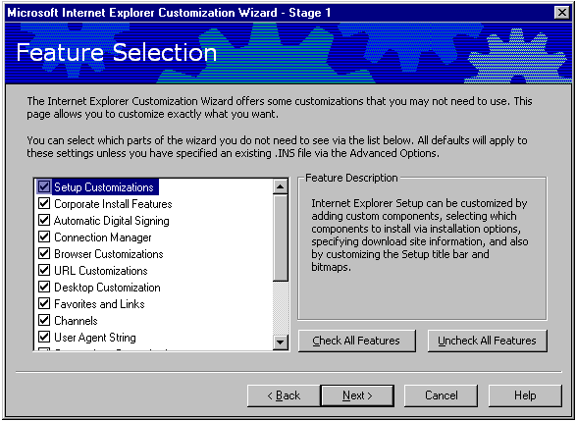
Administrators can determine which remaining screens of the Customization wizard are displayed by selecting or clearing the check boxes in this screen. This will make it faster and easier to complete the Customization wizard. Checking or clearing these boxes will not affect functionality; rather, these boxes will determine which items in the Internet Explorer Administration Kit Customization wizard can be customized.

Stage 2: Specifying Setup Parameters
The Internet Explorer 5 Setup engine provides some distinct advantages over previous installation methods. Specifically, IE5setup.exe is a small, Web-based setup package that lets users install the latest Internet Explorer components directly from a Web site. It is small (about 400K) so it can be run from a single floppy disk, distributed via e-mail, or downloaded quickly over the Internet. Internet Explorer Setup not only manages the entire installation process, but it can search to see which components are already installed, and alert users or administrators when newer versions are available. When Internet Explorer 5 Setup downloads Internet Explorer 5, it breaks it up into several small segments. This makes it possible, in the event of a failure or dropped connection, to restart an installation from where it was interrupted, instead of having to start over from the beginning.
Internet Explorer Administration Kit Customization wizard pages in Stage 2:
- Specifying Setup Parameters
- Microsoft Download Site
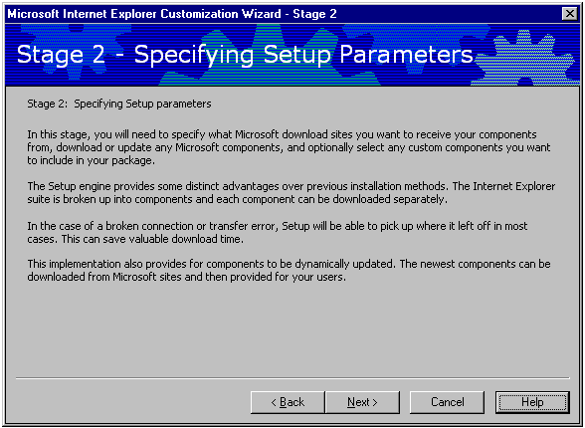
- Automatic Version Synchronization (AVS)
- Add Custom Components

In this stage, administrators will need to specify the desired Microsoft download sites in order to get components. The Internet Explorer Administration Kit does not check the validity or availability of any Web servers specified. When unsure of the locations needed to specify for download in this section, read the “Stage 6: Browser Distribution section” of this paper and plan the Web server configuration by using the Checklist before proceeding with Step 2. If a package with an incorrect URL is created, the package should be re-created to correct the error. Administrators will also need to download or update any Microsoft Internet Explorer components and optionally select any custom components to include in the package.
Also, the UNIX functionality in the Internet Explorer Administration Kit supports the more common UNIX method of installing the customized product on only a few servers. Users can then run Internet Explorer from this location rather than installing the product locally. This configuration is recommended for UNIX installations. Internet Explorer 5 Setup, which downloads .cab files, is not available on the UNIX platform.

Microsoft Download Site
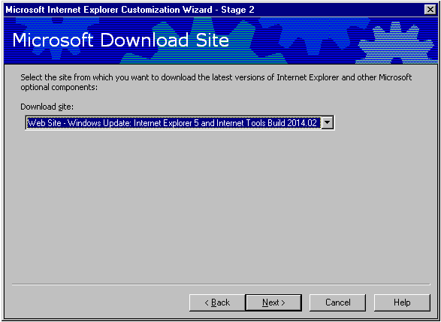
The Internet Explorer Administration Kit automatically loads the list of sites from which an administrator can choose. Pull down the Web site that the latest versions of Internet Explorer and other Internet Explorer components will be downloaded from. The Internet Explorer Administration Kit requires administrators to synchronize at least the Internet Explorer 5 Web Browser components the first time when creating a package, as well as whenever the component download folder is changed.

Automatic Version Synchronization
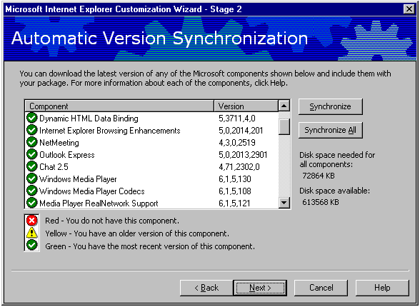
Option | Explanation
Synchronize | Synchronizes only the specific Internet Explorer components highlighted. The wizard downloads the latest version(s) of the component(s) selected.
Synchronize All | Synchronizes all Internet Explorer components. The wizard downloads the latest version of all of the Internet Explorer components without any version checking.

In this step, you will download the latest Microsoft programs and tools. This wizard page shows quickly whether any updates have been posted for the Internet Explorer 5 components. Although it is recommended that an organization use the latest possible version of Internet Explorer 5, administrators may wish to generate new packages using older versions of a component to ensure version continuity across the enterprise. It is important to remember that there is no rollback option to earlier versions of these components. Newer versions of these components will overwrite older versions as they are downloaded. To keep the older versions of these components, specify a different Download location for the newly synchronized.
In addition, Internet Explorer 5 Browser and Components can only be rolled back to earlier versions by uninstalling Internet Explorer and reinstalling an earlier package. For this reason, each package generated should be saved into a separate subdirectory with enough versioning documentation to determine what is in it throughout the life of the product.
If you already have the latest version of a component, you will be prompted to keep it. You may need to temporarily disable virus-checking programs to download components; a message will be displayed if this is necessary.
Microsoft Download Site. Choose the site that you will download the latest Internet Explorer and Internet Tools from, and click Next to see the Automatic Version Synchronization.
Download Internet Explorer components. Download the latest version of any Microsoft components shown in the box. The status of each component is indicated as follows:
- Red X. This component is not currently downloaded.
- Yellow exclamation point. An outdated version of this component has been downloaded.
- Green check mark. The latest version of this component has already been downloaded.
You must download the Internet Explorer browser to continue beyond this step.
Notes
- To download or update more than one component, select each component you want, and then click Synchronize. To download all components, click Synchronize All.
- For information about components and ComponentID strings, see the Internet Explorer Administration Kit Web site.
- If you cleared the Automatic version synchronization (AVS) check box in the first stage of this wizard, the Internet Explorer Customization wizard will not be able to verify whether you have the latest version of the components. The icons will not be green, even if you have the latest version. For those components that you have already downloaded, the icons will be yellow. For components you have not downloaded, the icons will be red. Also, if you have disabled version synchronization, you will not be able to download specific components in this stage of the wizard.
- In this stage of the wizard, the Setup files for Internet Explorer and other components are downloaded to your computer. It's recommended that you keep a copy of these files on your hard disk. This will make it easier to rebuild your package later and to enable the Customization wizard to check whether newer versions of these programs are available.

Add Custom Components
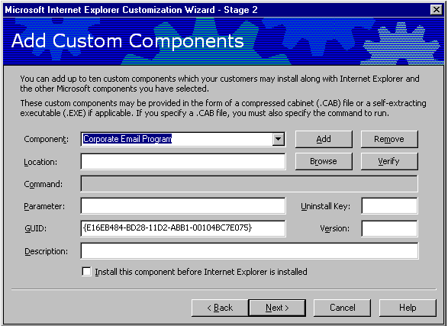
You can add up to ten custom components that your users can install at the same time that they install the browser. These components can be compressed cabinet (.cab) files. For 32-bit versions of the browser, these components can also be self-extracting executable (.exe) files.

Option | Explanation
Component | Enter the name of the component in this box. This name will appear in the setup screen when users install the software.
Location | Click Browse, or type the path to the self-extracting .exe file or the .cab file for the component.
Command | For .cab files only. Type the command needed to run the .cab file.
Parameter | You can specify any switches to run with your custom program. For example, you might want to install your program "silently," with few or no prompts, so that users don't see prompts for your program or for Internet Explorer. To specifically exclude setup prompts, you would use the /q:a switch.
GUID (Global Unique Identifier) | If your program already has a globally unique identifier, or GUID, type it in this box. If your program doesn't have a GUID, one will be generated for you. A GUID establishes a unique identity for programs, objects, and other items.
Description | Type up to 511 characters to describe your component. This text will appear in Setup when the user points to the component.

Verify | Programs installed over the Internet typically need "digital signatures" that identify their source and guarantee that the code hasn't changed since it was signed. Depending on browser safety settings, users can be warned before the program is downloaded. Certification authorities can supply public and private keys needed to sign code. To determine whether the program has been digitally signed, click Verify. If you sign the rest of your files when you run the Internet Explorer Customization wizard, then this component will also be signed with that certificate.  For general up-to-date information about code signing, see the Microsoft Web site.
Uninstall Key | Registering your uninstall program enables users to remove your program by clicking the Add/Remove Programs icon in Control Panel. To register your uninstall program, your application needs to add the following entries for the Uninstall subkey during Setup. For a sample uninstall file, see the Uncheck.inf file in the Inf folder of the Internet Explorer Administration Kit.  HKEY_LOCAL_computer\Software\Microsoft\Windows\CurrentVersion\  Uninstall\ApplicationName,UninstallString  - ApplicationName = the display name of your program  - UninstallString = path [ switches ]  Both the DISPLAYNAME and UNINSTALLSTRING values must be supplied and be complete for your uninstall program to appear in Control Panel. The path you supply to UninstallString must be the complete command line used to carry out your uninstall program. The command line you supply should carry out the uninstall program directly rather than from a batch file or subprocess.  The Uninstall Key field on this page should match the ApplicationName value if you want this program to be uninstalled when Internet Explorer is uninstalled.
Version | Setup uses the version number to compare what is being installed with what is currently installed on the computer. When reinstalling a component, Setup will not install an older version. The version number helps you track versions of your program to ensure that the latest version is installed. The correct format for entering this version number is: xxxx,xxxx,xxxx,xxxx.
Install this package before Internet Explorer | If you need to install a custom component before Internet Explorer is installed (for example, to run a batch file to preconfigure user settings), select this check box.

For 32-bit versions, it is recommended that you sign any custom code that will be downloaded over the Internet. Code-signing lets users know they can trust your code before downloading it to their computers. The default settings in Internet Explorer will reject unsigned code.
For the UNIX platform, you should create a cabinet file that contains your add-on components and installation scripts. Then, specify the name of the cabinet file, the script name, and size information on this page of the wizard. You can specify up to ten components. For more information, see Preparing a UNIX Component for Installation in the Internet Explorer Administration Kit Help.

Stage 3: Customizing Setup
In this stage of the Internet Explorer Customization wizard, corporate administrators can determine the way that Setup will appear and work:
- Customize the CD-ROM Autorun screen if you are creating a CD-ROM package.
- Customize additional CD-ROM options if you are creating a CD-ROM package.
- Customize Windows Update Setup Wizard for Internet Explorer and Other Internet Tools.
- Determine whether you want to install the package "silently," with few or no prompts to the user.
- Specify up to ten installation options and determine which components are included with each option.
- Specify up to ten sites from which your package will be downloaded. You can specify up to ten sites, unless you are a corporate administrator performing a silent install.
- Specify how users will receive updates to their components.
- Specify where you want Internet Explorer to be installed on your users' computers and whether users can change the installation location.
- Determine whether users can customize Setup, whether uninstall information is installed, whether Internet Explorer can be installed side-by-side with a previous version, and whether Internet Explorer is the default browser.
- Specify that Setup detects if a component exists and fine-tune which components users can customize.
- Determine whether components you've downloaded, but haven't added to all packages, will be made available to users through the Automatic Install feature.
- Import a custom profile from or create a new profile with the Connection Manager Administration Kit (CMAK). The CMAK is installed with the Internet Explorer Administration Kit.
- Specify whether you want to integrate Web browser functionality into your desktop and folders. This functionality is integrated into Windows 98.
- Specify certification authority information, if you have a digital certificate, so you can sign programs as you build your Internet Explorer Administration Kit package.
Notes
- The UNIX functionality in the Internet Explorer Administration Kit supports the more common UNIX method of installing the customized product on only a few servers. Users can then run Internet Explorer from this location rather than installing the product locally. This configuration is recommended for UNIX installations. Internet Explorer 5 Setup, which downloads .cab files, is not available on UNIX operating systems.
- Unlike Internet Explorer 32-bit versions of the browser, 16-bit and UNIX versions of the browser do not perform digital signature verification. Programs or cabinet files for these operating systems do not need to be signed.

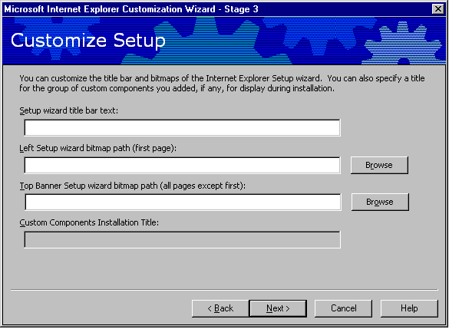
Customize Setup

You can customize how Setup appears to your users. You can change the title bar and the graphic that appears when users run the Windows Update Setup wizard. If you provide a group of customized components, you can assign a name to them.
Option | Explanation
Setup wizard title bar text | This text appears in the title bar of the Setup wizard your users run. This text does not appear in the title bar of the customized browser. You can customize the browser title later in the Internet Explorer Customization wizard.
Left Setup wizard bitmap path | These graphics will customize the appearance of the Setup wizard. You should avoid using graphics with complex lines and patterns. 32-bit versions of the browser: The Setup wizard contains two 256-color bitmaps. The left vertical bitmap (on the first Setup wizard page) is 162 x 312 pixels. The top horizontal bitmap (on the remaining Setup wizard pages) is 496 x 56 pixels. The horizontal graphic appears behind some Setup instructions, so use a bitmap that won't interfere with readability. 16-bit versions of the browser: The Setup wizard contains one bitmap that is 162 x 312 pixels. A 16-color bitmap is recommended.
Top Banner Setup wizard bitmap path | Type the path to a bitmap or click Browse to locate the path to the image. The bitmap must be 496 x 96 pixels.
Custom Components Installation Title | You can install custom components when you install the customized browser. If you have specified more than one custom component, you can name them as a group; for example, you might have a group of components named Volcano Coffee Company Inventory Programs. This name appears in the Setup wizard when your users install their custom packages. Enter the title you want to appear.

Silent Install
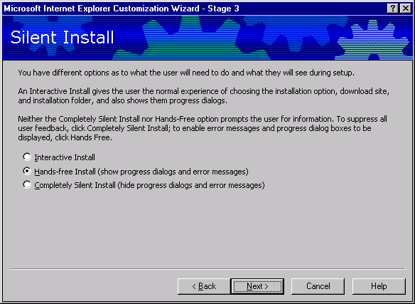
This screen allows administrators to specify how much interaction users can have with the installation.
- If you want to provide an interactive installation for your users, in which they make installation decisions, click Interactive install.
- If you want to provide a "hands-free" installation, in which users aren't prompted to make decisions but are informed of the installation progress and errors, click Hands-free install.
- If you want your users to install the customized browser without receiving prompts, click Completely silent install. You should select this option when you want to control all setup options and suppress feedback to the user. Selecting this check box is the same as installing Internet Explorer with the /Q:A switch. This mode is not interactive, and users will not have control over its progress. If installation does not finish successfully, users will not see an error message. You might consider using this feature for installations deployed when the user is not present. To fine-tune the installation, you can use additional Internet Explorer batch setup switches.
A silent installation (Hands-free or Completely silent) does the following:
- Answers prompts that enable Setup to continue.
- Accepts the license agreement.
- Specifies that Internet Explorer will be installed and not just downloaded.
- Carries out the type of installation that you specify (such as Standard or Custom). You will set this option later in the Internet Explorer Customization wizard.
- Installs Internet Explorer in the location you specify, unless Internet Explorer is already installed. In that case, the new version of the browser is installed in the same location as the previous version.
- Connects to the first download site specified in the Internet Explorer Administration Kit. You will provide a list of download sites later in the Customization wizard.
Note: In a silent install, you can specify only one installation option and one download site for your users.

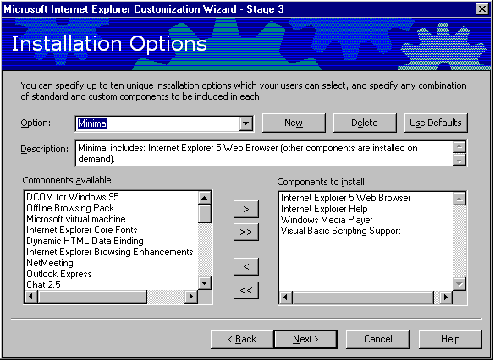
Installation Options

You can specify up to ten installation options, such as Standard and Custom, and determine which standard and custom components are installed with each. If you are a corporate administrator and you have specified a silent installation, you will have only one option. For the UNIX version of Internet Explorer, you will determine which available components will be a part of your Setup package. To move items from the Components available area to the Components to install area, click the arrows.
Option | Explanation
Option | Select the default installation option you want, or click New to create a new setup option. Type the description for the option, and then add or remove the components you want by clicking the arrows. Corporate administrators might want to specify setup options for different branches of your company.
Description | Type a description of the installation option, such as a list of components and programs that are installed. This text appears in the Windows Update Setup wizard that users will see. Provide enough information so that users can make a decision about which software to install.
Components available | The list of available components includes the Internet Explorer components you have downloaded and any custom components you have defined. To add components to this list, return to Stage 2 of the wizard.
Components to Install | This list shows the components that will be installed with the option that appears in the Option box. Click the single arrows to add or remove a single component or the double arrows to add or remove all available components.

Note: If you are installing Internet Explorer 5 on a computer that has never run Internet Explorer 4, and you want your users to have channels, add the Offline Browsing Pack to your installation.

Available Components
In addition to being able to specify up to ten custom components (see Add Custom Components in Stage 2), the Internet Explorer Administration Kit includes the following component options:

AOL ART Image Format Support | Internet Explorer Browsing Enhancements | Offline browsing pack
Arabic Text Display Support | Internet Explorer core fonts | Outlook Express
Chat 2.5 | Internet Explorer Help | Pan-European Text Display Support
Chinese (Simplified) Text Display Support | Japanese Text Display Support | Thai Text Display Support
Chinese (Simplified) Text Input Support | Japanese Text Input Support | Vector Graphics Rendering (VML)
Chinese (Traditional) Text Display Support | Korean Text Display Support | VRML 2.0 Viewer
Chinese (Traditional) Text Input Support | Korean Text Input Support | Vietnamese Text Display Support
DCOM for Windows 95 | Language Auto-Selection | Visual Basic Scripting Support
DirectAnimation | Macromedia Flash Player | Wallet
Dynamic HTML Data Binding | Macromedia Shockwave | Web Folders
FrontPage Express | Media Player RealNetwork Support | Web Publishing Wizard
Hebrew Text Display Support | Microsoft virtual machine | Windows Media Player
Internet Explorer 5 Web Browser | NetMeeting | Windows Media Player Codecs

Component Download Site
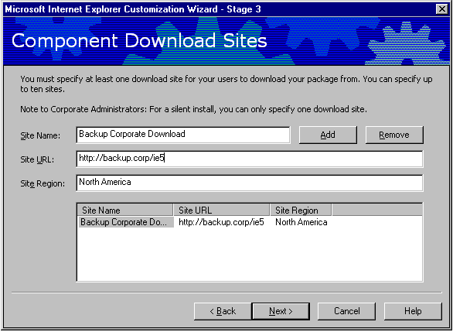
You must specify at least one download site, using an HTTP or FTP server, for your users to download your package from. You can specify up to ten sites. You must place all the Microsoft components and custom components at each URL you specify below. Note: The Internet Explorer Administration Kit will not check the validity of the listed Web server, nor will it copy the installation files to the Web server.
Option | Explanation
Site Name | You can specify a friendly name that helps to identify the site. Do not use commas in the name.
Site URL | Type the URL for your site. The file Ie5sites.dat will be added or updated and a subfolder for the language of the package, such as EN for English, will be appended to the URL.
Site Region | Type the location of the site, such as the city, state, region, or country.
Custom download sites | The sites you specify will be listed in this column. If the first site is down (for example, as a result of server problems), Setup will not be able to locate the remaining sites by default. A workaround involves overwriting the first site with the following command:  <path>\ie5setup.exe /c:"ie5wzd.exe /s:""<path>\ie5setup.exe"" /L:""http://my Web server/my Web site/ie5sites.dat"""  <path> is the folder where IE5setup.exe is located.  Here's an example:c:\ie5setup.exe /c:"ie5wzd.exe"  /s:""D:\Build\1700\package\download\win95_nt\en\ie5setup.exe""  /L:""http://<NewServerAddress>/<YourDownloadDir>/ie5sites.dat ""  Note: You can specify only one download site for a silent installation.

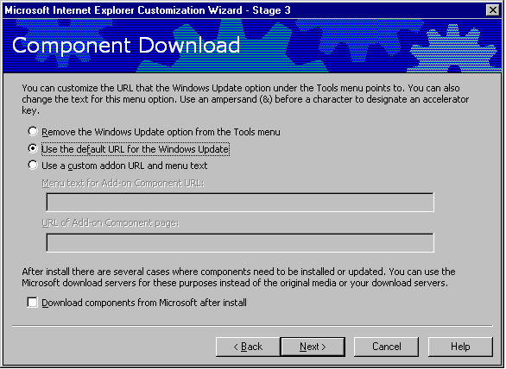
Component Downloads

When a new version of Internet Explorer is available, users can update Internet Explorer by clicking the Tools menu and then clicking Windows Update in 32-bit versions of the browser. Users may also see this page when they click Add/Remove Programs in Control Panel, click Internet Explorer 5 and Internet Tools, and then click Add/Remove.
The default location for obtaining product updates is on the site(s) where users downloaded their customized browsers, but you can specify your custom add-on page.
Option | Explanation
Download components from Microsoft sites after install | Selecting this check box specifies that all components will be downloaded from Microsoft sites after installation.
URL of Add-on Component page | If you want users to obtain software updates from another location, specify a different URL.

Note: The configuration ID and version number available in previous versions of the Internet Explorer Administration Kit, which formerly appeared on this screen, are no longer necessary. These values are generated automatically. The customizations, or branding, that you generate with the Internet Explorer Administration Kit will always get installed, regardless of version number or configuration ID.

Installation Directory
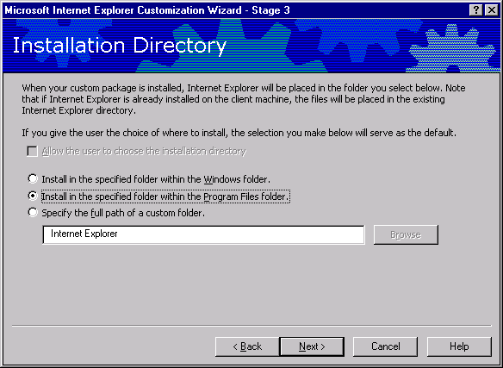
This screen lets administrators choose the installation path. Requiring the installation to occur in a specific location is a good idea because it helps enforce standards throughout an organization. A standard install path that cannot be changed by users makes things like service, patches, and remote software inventories easier to accomplish.
To allow the user to change the location that you specify, select the Allow the user to choose the installation directory check box. If you select this check box, the selection you make below appears as the default location.
If you click Install in the specified folder within the Windows folder or Install in the specified folder within the Program Files folder, Internet Explorer will be installed in the subfolder shown in the box.
If you select the Specify the full path of a custom folder check box, you can enter the path you want. If this path doesn't exist on the user's hard disk, it is created.
Notes: If Internet Explorer is already installed on the user's computer, the new version is installed over the existing version. The customized browser is not installed in the custom location you specify.
The UNIX functionality in the Internet Explorer Administration Kit supports the more common UNIX method of installing the customized product on only a few servers. Users can then run Internet Explorer from this location rather than installing the product locally. If you need to install Internet Explorer locally, specify the location on this screen of the wizard.

Corporate Install Options
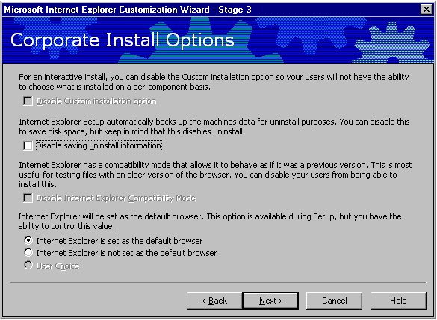
These options help control how Internet Explorer installation will interact with each client computer. Choices are usually made based on corporate policy, but here are a few things to keep in mind: if users can’t change components, there is better software standardization in an organization. Also, administrators can save a few megabytes on each client hard-drive by not saving uninstall information, but this limits the ability to roll back if there are compatibility issues during deployment. Finally, users typically like to be able to choose their favorite browser as the default; administrators typically like to choose it for them.
Option | Explanation
Disable Custom Installation option | Users can add or remove components to further customize setup. To prevent users from adding or removing specific components, select this check box.
Disable saving uninstall information | Setup automatically saves uninstall information. To save disk space, you can disable this feature by selecting this check box. However, users will not then be able to remove Internet Explorer 5 by clicking the Add/Remove Programs icon in Control Panel.
Disable Internet Explorer Compatibility mode | With the Internet Explorer compatibility option, users can run Internet Explorer 4 on the same computer as Internet Explorer 5. To disable this feature, select this check box.
Default browser options | Choose one of the three options to determine whether or not Internet Explorer is the default browser, and whether or not users can make this choice. The default browser runs when users open .htm, .html, and other associated file types. This option also determines whether Windows Media Player is the default program for playing multimedia files.

Note: If you are using a silent installation or customizing Internet Explorer for Microsoft Office deployment by using the Office Custom Install wizard, user options for Internet Explorer will not be displayed during Setup.

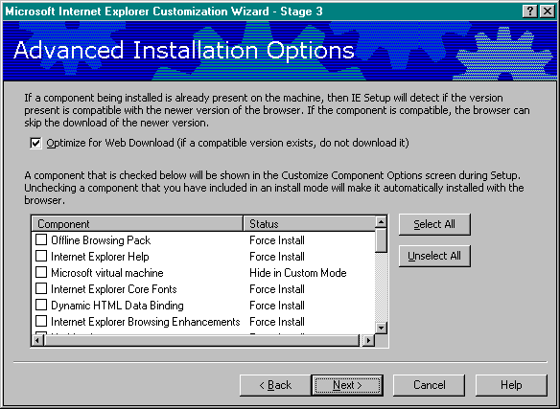
Advanced Installation Options

You can further customize Setup by having Setup detect whether a component exists and by fine-tuning which components users can add if they customize Setup. Internet Explorer Setup can detect whether the same version of a component is already installed on a user's computer. If the same component is already installed, then Internet Explorer will not download it. Even if users are allowed to customize an installation, the administrator can still prevent specific components from being removed. The administrator simply selects the components that users cannot customize.
Option | Explanation
Optimize for Web download | Setup can detect whether the same version of a component is already installed on your user's computer. If a version of the same component is already installed, and it will work with Internet Explorer 5, then Setup will not download it. This can save download time.
Prevent users from customizing Setup for specific components | If your users can customize their installations, but you don't want them to customize specific components, clear the check boxes for those components. Force Install will appear in the right column beside the components that will automatically be installed with the browser.

Components on Media
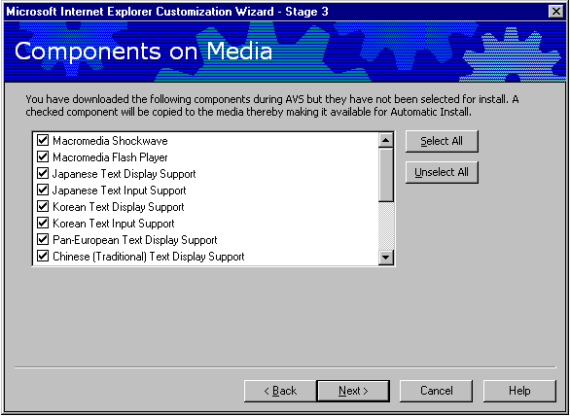
The components in this list have been downloaded to your computer but have not been included in a Setup option. The components you select can be made available for installation if users attempt to use a feature that requires these components; this feature is called Automatic Install.

Connection Manager Customization
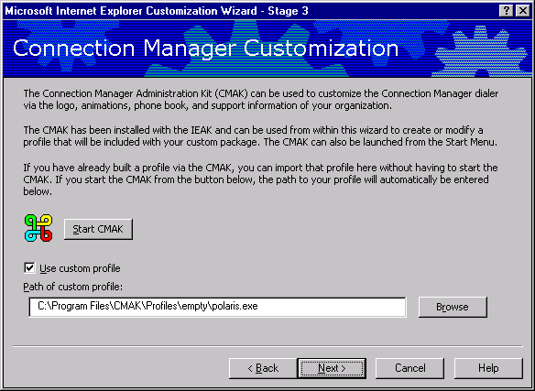
The Connection Manager Administration Kit (CMAK) can be used to create a customized and branded Connection Manager Services profile for users. This is useful when a corporate administrator wishes to automatically distribute, configure, and manage dial-up connections for users.
The CMAK is a separate program that is included with the Internet Explorer Administration Kit. The CMAK Wizard can be accessed from the Customization Wizard by selected the “Start CMAK” option, or an existing profile can be used by checking the “Use custom profile” checkbox and entering the path to the Connection Manager services profile.
When you use the CMAK, it creates a self-extracting executable (*.exe) file that installs itself on your user's computer. You do not need to digitally sign the .exe file created by the CMAK before you include it in the Internet Explorer Administration Kit. When you sign the Internet Explorer Administration Kit files, the CMAK file is also signed.
Option | Explanation
Use Custom Profile | If you've already created a custom profile, type the path of the profile you want to use for this browser package. The profile specifies customized content and connection methods.

Note: A CMAK profile is not the same thing as a Dial-up Networking connection. See Appendix B for more information on how to create a custom connection profile by using the CMAK, and Appendix D for more information on Automatic Connections.

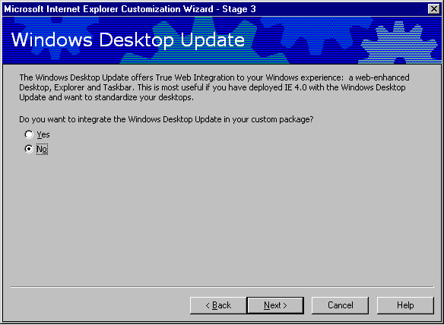
Windows Desktop Update

The Windows Desktop Update makes the desktop and folders look and work more like the Web. Although the Windows Desktop Update is not a part of Internet Explorer 5, you can include it with your Internet Explorer Administration Kit package. If your users are running Windows 98, they already have the desktop features.
If you choose to install the Windows Desktop Update, you can customize its settings later in the wizard, if your build computer is running one of the following configurations:
- Internet Explorer 5 upgraded from Internet Explorer 4.0 with the Windows Desktop Update installed.
- Internet Explorer 5 and Windows 98, which includes the new desktop.
This can be helpful in setting a corporate standard desktop.
Option | Explanation
Do you want to integrate the Windows Desktop Update in your custom package? | To install the Windows Desktop Update, click Yes. If you don't want to install it, click No.

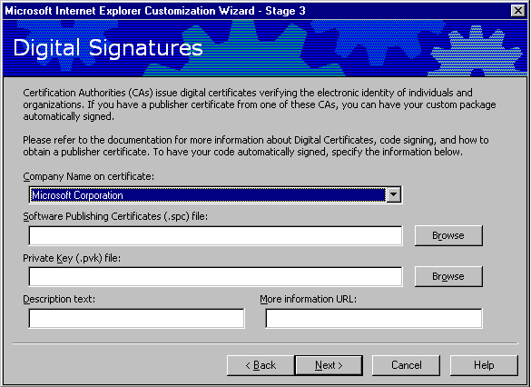
Digital Signatures

With a publisher certificate from a recognized Certification Authority, administrators can have custom packages automatically signed. Digital signatures show where programs come from and verify that they haven't been altered. Customized browser packages and any custom programs should be digitally signed to ensure that users don't receive warnings when installing the custom browser. Users may be prevented from installing ActiveX controls and Java packages that aren't signed.
To prepare certificates, you can import them onto your computer by using the Certificate Manager Import wizard. If you have received a file with an .spc extension, you can start the Certificate Manager Import wizard by double-clicking the .spc file in Windows Explorer or My Computer.
You can also open the Certificate Manager from Internet Explorer. To do this, click the Tools menu, click Internet Options, click the Content tab, and then click Certificates. Click Import to start the Certificate Manager Import wizard, and then follow the steps in the wizard.
Option | Explanation
Company Name on certificate | If a publisher certificate is on the computer, its company name will appear in this list.
Software Publishing (.spc) file | Enter the name of the .spc file associated with the certificate, or click Browse to locate.
Private Key (.pvk) file | Enter the name of the .pvk file associated with the certificate, or click Browse to locate.
Description text | Enter the text that will appear on the dialog box that appears when users download programs that are signed with this certificate.
More information URL | Enter the URL that will appear in this dialog box so that users can obtain more information about the certificate and the company.

Stage 4: Customizing the Browser
In this stage, corporate administrators can customize the following:
- The browser title bar, toolbar background bitmap, browser toolbar buttons, and the Internet Explorer logo in the upper right corner of the browser.
- Home, search, and online support pages for the browser.
- Favorites, Favorites folders, and links for the Links bar.
- Welcome page, which appears when users start their browser for the first time.
- Automatic configuration. You can provide a path to files that automatically configure your browser.
- The user's connection settings.
- Proxy settings.
- Desktop toolbar settings.
- Active Desktop customization, if you are also installing the Windows Desktop Update. You must have the Active Desktop installed on the build computer for this screen to be displayed.
- Settings for security certificates, Authenticode™ technology, security zones and ratings.

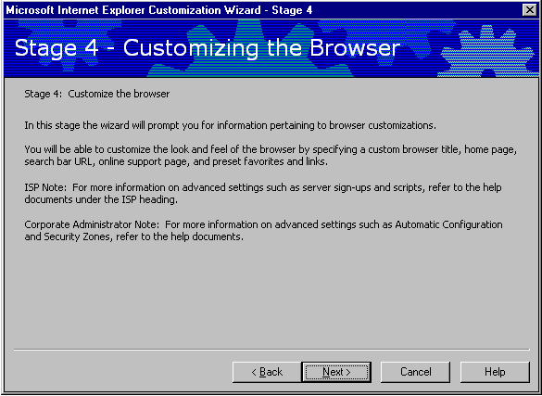

Browser Title
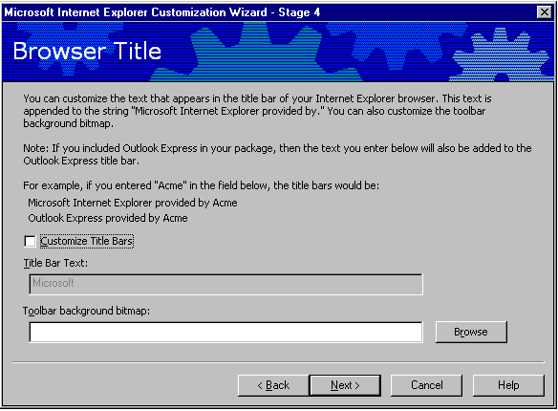
You can customize the text that appears in the title bar of the Internet Explorer Web browser and Outlook Express, if you include Outlook Express in your package. Type the text that you want to appear. It will be added after the text "Microsoft Internet Explorer Provided by" or "Outlook Express Provided by."

Option | Explanation
Customize Title Bars | To customize the title bars, select the Customize Title Bars check box, and then type the text you want in the Title Bar Text box.
Toolbar background bitmap | Type the path to the bitmap (or “Watermark”) to be displayed in the background behind the Internet Explorer toolbar buttons, or click Browse to locate it.

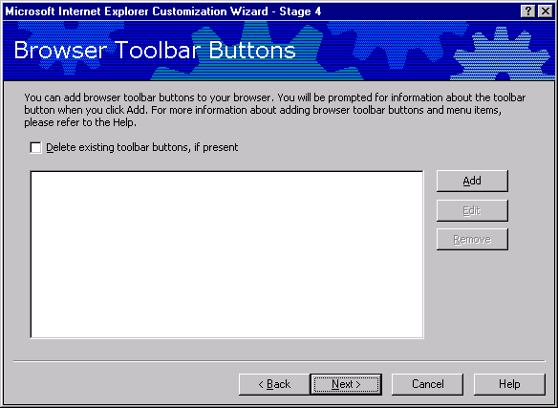
Browser Toolbar Buttons

You can customize the toolbar buttons in the user's browser. You can specify the script or program that the buttons launch, as well as their appearance. For more information about designing custom programs, see Microsoft Site Builder Network Workshop.

Option | Explanation
Delete existing toolbar buttons, if present | To delete the existing toolbar buttons in the user's browser, select this check box.
Add | You can add custom toolbars that run scripts or executable files. When you click Add, you will be prompted for more information, such as the icon, caption, and action for the button to perform.

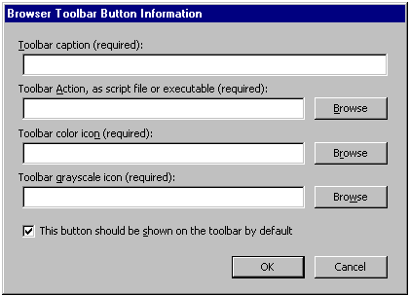
Administrators can add browser toolbar buttons to the browser. When “Add” is selected, the following options appear

Option | Explanation
Toolbar Caption (required) | This is the name of the toolbar button. You must specify a caption, or label, that will appear underneath the button when the user displays both the text and the icon on toolbar buttons. The maximum recommended size is ten characters.
Toolbar Action, as script file or executable (required) | You must specify the script or executable file that will run when the user clicks the toolbar button.
Toolbar color icon (required) | You must specify a color icon that will appear on the toolbar buttons. The icon consists of 20-pixel-by-20-pixel images for active and inactive states.
Toolbar grayscale icon (required) | You must specify a grayscale icon for the toolbar that will display on black-and-white monitors.
This button should be shown on the toolbar by default | Select this check box to enable the toolbar button you've specified to be shown in the user's browser by default.

Animated Logo
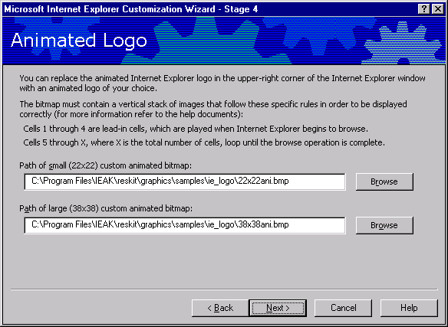
All Internet Explorer corporate administrators will have the ability to customize the animated logo that appears in the upper-right corner of the Internet Explorer window. This ability was limited to customers with special licensing agreements in Version 4.
With an animated bitmap, the first frame appears as static when no action is taking place in the browser; the remaining frames appear as animated when the browser is in use. Two animated bitmaps are required for a custom animated logo: one at 22 x 22 pixels and the other at 38 x 38 pixels. The paths of the small and large custom animated bitmaps need to be typed in the boxes provided. Sample animated bitmaps are available in the Internet Explorer Administration Kit Toolkit, which is installed in the \Ieak\Toolkit folder on the hard disk when the Internet Explorer Administration Kit is installed.
Two tools are included with the Internet Explorer Administration Kit to help administrators create customized animated bitmaps for the browser. One is used to stack bitmaps in the format described above; the other previews the animation. Information about how to use these tools is included in “Animated Bitmap Tools” in the Internet Explorer Administration Kit Help section.

Static Logo
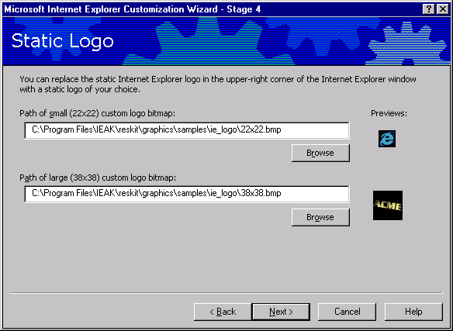
The Internet Explorer logo in the upper right corner of the browser appears in two states: animated when the browser is in use, and static when no action is taking place. You can replace the logo bitmap with your own animated or static bitmap.
- Customize the animated logos. If you use an animated bitmap, the first frame appears static when no action is taking place in the browser; the remaining frames appear animated when the browser is in use. To use your own animated logo, you must provide two animated bitmaps: one should be 22 x 22 pixels and the other 38 x 38 pixels. Type the paths of the small and large custom animated bitmaps in the boxes provided. Sample animated bitmaps are available in the Internet Explorer Administration Kit Toolkit, which was installed in the \Ieak\Toolkit folder on your hard disk when you installed the Internet Explorer Administration Kit.
- Customize the static logos. If you use a static bitmap, it will appear static whether or not any action is taking place in the browser. To use your own static logo, you must provide two bitmaps; one should be 22 x 22 pixels and the other 38 x 38 pixels. Type the paths of the small and large custom static bitmaps in the boxes in this panel.
Notes: Two tools are included with the Internet Explorer Administration Kit to help you create customized animated bitmaps for your browser. One tool is used to stack bitmaps in the format described above, while the other tool previews the animation.

Important URLs
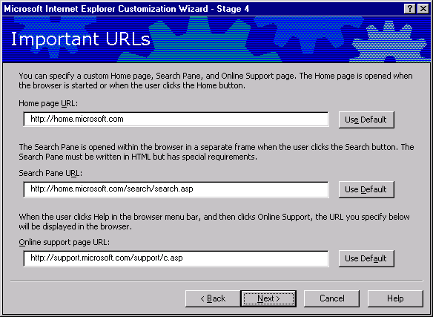
You can specify the URLs for the home, search, and online support pages.

Option | Explanation
Home page URL | To use the default Internet Explorer home page, click Use Default. To use another home page, type the URL of the home page.
Search Pane URL | The Search bar appears in the Explorer bar on the left side of the screen. This bar enables a user to see the search query and search results at the same time. The Search bar comes with a choice of search engines. In Internet Explorer 5, Search results are written so that they appear in the main browser window, rather than in the Search pane.  If you want to use the Internet Explorer default Search bar, click Use Default.To use another Search bar, type the URL of the Search bar.
Online support page URL | In Internet Explorer, support information is available by clicking Help, and then clicking Online Support. It's recommended that you develop a support page and make it available to your users.  Type the URL of your custom support page in the Online support page URL box. If you want to use the Internet Explorer default support page, click Use Default.

Note: The Test URL button has been removed from the Internet Explorer Administration Kit in Version 5. Administrators should be sure to verify that the URLs are typed in correctly before distributing the package to users.

Favorites and Links
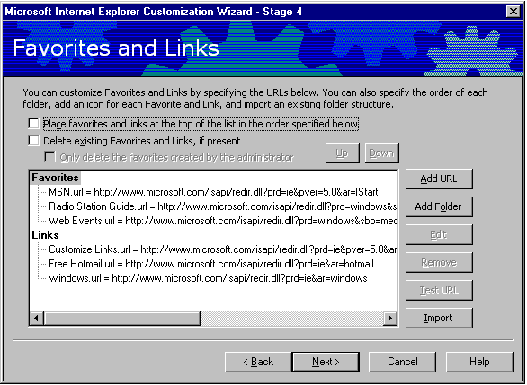
You can customize the Favorites folder and Links bar by adding links to sites related to your company or services.
The Links bar appears by default at the top of a user's screen, and it comes with a set of default links. You can add links to the default folders or add new folders. When a user clicks Favorites, the Favorites list appears on the left side of the window.

Option | Explanation
Place favorites at top of list | Select this check box to specify that the Favorites you choose are moved to the top of the users' Favorites list, so they are easier for users to find.
Delete existing Favorites and Links, if present | Select this check box to delete the items on the users' Favorites and Links lists. It is recommended that you use this setting with caution, because it removes the links and favorites that the users have set up.

To add a folder to the Favorites list or Links bar
- Click Favorites, Links, or a folder within Favorites or Links, and then click Add Folder.
- Type the name of your folder in the Name box. This can be a friendly name that helps the user recognize what types of links are in the folder.

Notes
- You can import a folder containing links by clicking Import, or you can click an existing folder to create a new subfolder.
- Semicolons and slashes are not allowed in the titles.
To add a Web page to the Favorites list or Links bar
- Click Favorites, Links, or a folder within Favorites or Links, and then click Add URL.
- Type a name for this Web page in the Name box. This can be a friendly name that helps the user recognize what the link refers to.
- Type the path of your link in the URL box.
- To specify a 16-pixel-by-16-pixel custom icon, type the name of the file in the Icon box.
- To make this page available to users when they aren't connected to the Internet, select the Make available offline check box. This option is often helpful for users with laptop computers.

Notes
- To test a link, click the URL in the list, and then click Test URL.
- You can add up to 200 links to the Favorites folder.
- To remove an item from the Favorites list or Links bar, right-click the item, and then click Delete.

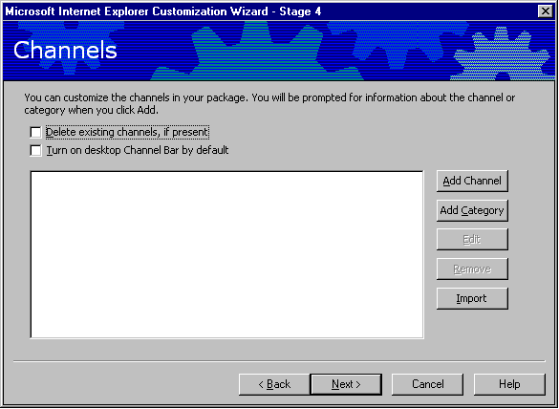
Channels

You can add a custom channel or channel category (folder), or import the channel settings from your computer. When you import channels, you can further customize them; for example, you could import your channel settings but delete one of the channels you import. To add channels, you should already have information about your channel or channel category, such as the path to the images and the titles you want to use. You should also have a Channel Definition Format (.cdf) file for each channel.
If your custom Internet Explorer 5 package might be installed on a computer on which Internet Explorer 4 has never been installed, and you want your users to be able to use channels, you should add the Offline Browsing Pack to your installation. This feature is part of Internet Explorer 4, but it is a separate component of Internet Explorer 5.
To guarantee that channels will work, you must make sure that the Offline Browsing Pack is included in your installation. If you let users customize their setup choices, you need to specify that this option won't appear as a custom installation choice. To do this, on the Advanced Installation Options wizard page, clear the Offline Browsing check box; Force Install will appear in the right-hand column.
When you create channels that will be viewed by Windows 3.1 and UNIX users, make sure that the channels will be displayed correctly on those platforms.
Option | Explanation
Delete existing channels, if present | You can delete existing channels on the user's computer by selecting this check box.
Turn on Desktop Channel Bar by default | If you are a corporate administrator, and you are setting up the Windows Desktop Update or installing Internet Explorer 5 on Windows 98 computers, you can set up the Channel bar on the user's desktop by default.

Adding a Channel
To add a channel, click Add channel, and then specify the following information:
Option | Explanation
Channel Title (required) | Specify the title of your channel. This will appear in the user's Favorites list.
Channel Definition File on Web Server URL (required) | Type the URL of the .cdf file for this channel. The .cdf file provides information about when and how to update your content.
Channel Definition File Path | Type the path (on your hard drive or network) where the .cdf file is now located, or click Browse to locate it.
Narrow Channel Image Path | Type the path for the narrow channel image, or click Browse to locate it.
Channel Icon Path | Type the path for the channel icon, or click Browse to locate it.
Make available offline | Select this check box to make the channel available offline. When content is made available offline, users can read it when their computer is not connected to the Internet. For example, they can view content on their laptop computer when they don't have a network or Internet connection.
Notes
- When you specify a .cdf file for a custom channel, make sure that the .cdf file does not contain the LOGO tag with the IMAGE or ICON parameter.
- If you are adding a channel within a channel category, use the following syntax: <category name>\<channel name> -
for example, My Category\My Channel.

Add a channel category (a folder of channels)
To add a channel category, click Add Category, and then specify the following information:
Option | Explanation
Category Title | Type the title of the channel category.
Category HTML Page | Type the URL for the HTML page of your category.
Narrow Category Image Path | Type the path to your narrow category image.
Category Icon Path | Type the path to the icon that will be displayed for your category.
Edit a channel | To edit a channel or channel category that you've added or imported, click Edit. The dialog box with the image and path settings will be displayed.

Remove a channel
To remove a channel or category that you've added or imported, select the item, and then click Remove.

Import channels
To import the channel settings from your computer, click Import. If you want to change your channel settings before importing them, you do not need to close the wizard. Just switch to your browser, change your channel settings, and then switch back to the wizard.

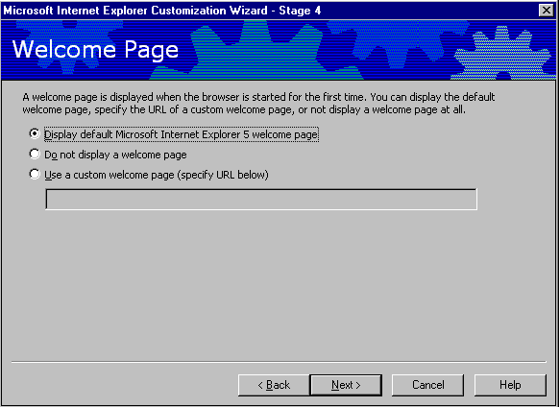
Welcome Page

Internet Explorer displays a welcome page when the browser is first started. You can display the default Internet Explorer welcome page, or you can specify your own custom welcome page. The welcome page can be different than the home page, which is the page that opens when the user starts the browser after the first time or clicks the Home button.
Option | Explanation
Display default Microsoft Internet Explorer 5 welcome page | Select this option to display the default Internet Explorer welcome page.
Do not display a welcome page | Select this option if you don't want to display a welcome page. The first page that is displayed is the user's home page.
Use a custom welcome page | Select this option if you want to use a custom welcome page, and then type the URL in the box below.

Note: The “Welcome to Internet Explorer” startup dialog that had to be run twice in Internet Explorer 4.0 is not displayed in Internet Explorer 5.

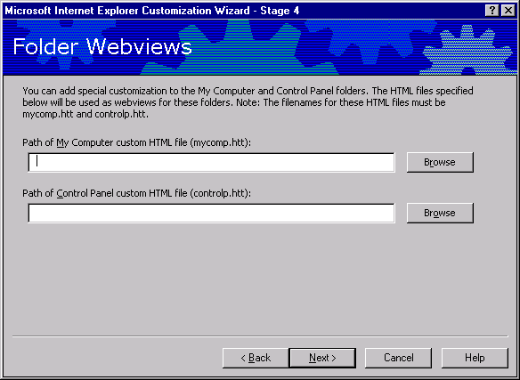
Folder Webviews

You can customize how My Computer and Control Panel appear on your company's computers by customizing the files that serve as templates for them. Then if the user installs the Windows Desktop Update, My Computer and Control Panel can appear as Web pages. One reason to customize these folders is to provide instructions, a company logo, or links to support or corporate sites. You must include the Windows Desktop Update in your browser package, and be running the desktop on your build computer, to specify Folder Webviews.
To specify a Webview, use the following template files:
- Mycomp.htt for My Computer
- Controlp.htt for Control Panel
If you have installed the Windows Desktop Update on your computer, these files are located in the C:\Windows\Web or C:\Windows\NT folder. You can open them using a text editor, such as Notepad, or an HTML editor. It's recommended that you make a back-up copy of these files before working with them, so you can restore them to their original state if needed.
There are several ways you can modify these files to suit your company's needs. You can add your own links or graphics, change colors, and even determine which contents (icons and file names) are displayed. For example, you could choose not to display the icons in Control Panel, but provide graphical buttons the user could click for only those settings you choose to make available.
These files use active scripting, such as JavaScript, JScript®, or Visual Basic® Scripting Edition (VBScript). The existing Mycomp.htt and Controlp.htt files, and other files related to the desktop (Folder.htt and Printers.htt), use JavaScript. You can modify some aspects of these files without scripting, or if you're familiar with scripting, you can add to or change the scripting to meet your needs.
These template files are very similar to .htm files, except for three variables: %THISDIRNAME%, %THISDIRPATH%, and %TEMPLATEDIR%, which are processed through a MIME filter and replaced with the correct file or path information. These variables are useful when you specify links to external files, such as graphics. Although these template files are located in the C:\Windows\Web or C:\Windows\NT folder, they are processed in the \Temp folder, so the path information is necessary to ensure that links to other items work.
An important issue is to ensure that the customized versions of My Computer and Control Panel resize the display in accordance with your users' screen resolutions, and that they appear correctly. In the Mycomp.htt and Controlp.htt files, the following syntax is used to ensure proper resizing:
<script language="JavaScript">
window.onresize = fixSize;
</script>
These files use the FileList object to represent the contents (icons and file names) of My Computer and Control Panel. In My Computer, a pie chart showing the amount of free space available is represented by the PieChart object. These objects are optional.
For more information about scripting, see the Microsoft Site Builder Network Workshop.
In My Computer and Control Panel, Infotips from the registry are displayed when the user points to the item. The Infotips provide a brief description of the item.
You can also modify the Printers.htt (Printers) and Folder.htt (default Web view for folders) template files in the C:\Windows\Web or C:\Windows\NT folder on your computer or on your users' computers. These files cannot be included in your customized Internet Explorer Administration Kit package.
If you want, you can provide an HTML file instead of modifying the *.htt files. To do this, you need to change the associated PersistMoniker references in the registry to PersistFile, and point the references to your customized file.
Note: Editing the registry can cause harm to an operating system, and should be performed at your own risk.

User Agent String
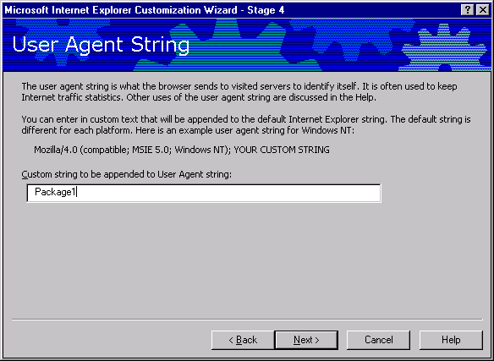
Some companies track site statistics, such as how many times their content is accessed and by which types of Web browsers. User agent strings help identify the browser type.
Custom string to be appended to user agent string
The string you type in this box is appended to the user agent string for the customized browser. You do not need to customize the user agent string unless you want to track the usage of your custom browser and you gather browser statistics from other Internet sites. Be aware that other companies that track site statistics will see the customized string.

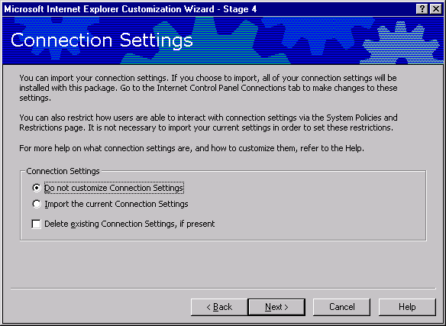
Connection Settings

You can preset connection settings for your users by importing the connection settings from your computer.
To see which settings you'll import, click the Tools menu in the browser, click Internet Options, and then click the Connections tab. Click Settings to view dial-up settings, and LAN Settings to view network settings. The address for automatic configuration is not imported, however.
If you do not want to preset your users' settings, click Do not customize Connection Settings.
To import the settings on your computer, click Import the current Connection Settings. If the settings displayed are not the settings you want to use, you can change them here. Importing an existing connection setting is the recommended way to set up an automatic dial-up networking connection for remote users. More discussion on automatic connection is included in Appendix D: Automatic Connections.
You can clear the existing settings on your users' computers by clicking Delete existing Connection Settings, if present.

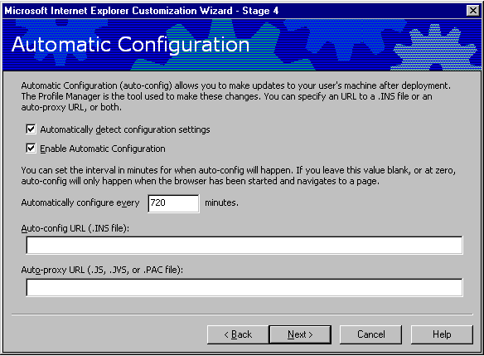
Automatic Configuration

You can assign URLs to files that will automatically configure the customized browsers. This feature is helpful if you want to control the settings of several users from one central location. You can configure options by using .ins files, also known as Internet Explorer Administration Kit profiles. Using .ins files, you can include standard proxy settings. For 32-bit and 16-bit versions of the browser, you can also specify script files in .js, .jvs, or .pac format that enable you to configure and maintain advanced proxy settings.
Network servers using Domain Name System (DNS) and Dynamic Host Configuration Protocol (DHCP) can automatically detect and configure a browser's settings when the user first starts the browser on a network.
Option | Explanation
Automatically detect settings | To automatically detect browser settings, select the Automatically detect configuration settings check box.
Automatically configure | You can specify the interval in minutes for the automatic configuration feature. If you enter zero, or don't enter a value, automatic configuration happens only when the user's computer is restarted.
If you specify URLs for both automatic configuration and automatic proxy (auto-proxy), the auto-proxy URL will be incorporated into the .ins file. The correct form for the URL is http://share/test.ins.
To enable automatic configuration, select the Enable Automatic Configuration check box. Type the URL for the .ins file you want in the Auto-config URL (.ins file) box. Type the URL for the autoproxy script in the Auto-proxy URL (.js, .jvs, or .pac file) box.

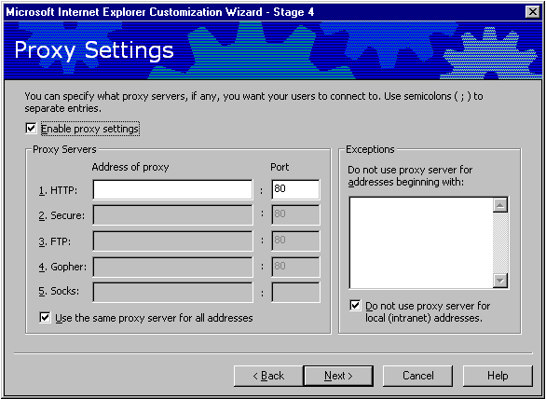
Proxy Settings

You can specify which proxy servers your users connect to. A proxy server acts as a security barrier between your internal network (intranet) and the Internet, keeping other people on the Internet from gaining access to confidential information on your internal network.
Option | Explanation
Enable Proxy Settings | If you do not use proxy servers, clear this check box.
HTTP | Type the URL of the proxy server for HTTP and its port number.
Secure | Type the URL of the secure proxy server and its port number.
FTP | Type the URL of the proxy server for FTP and its port number.
Gopher | Type the URL of the proxy server for Gopher and its port number.
Socks | Type the URL of the sock proxy and its port number.
Use the same proxy server for all addresses | To use different proxy servers for different services, clear this check box.
Exceptions | Type the path(s) or domain(s) that do not require the use of proxy servers.
Do not use proxy server for local (intranet) addresses | In certain cases, you may not want to use a proxy server, such as for addresses on your corporate intranet. You can enter specific addresses in the box under Do not use proxy server for addresses beginning with. Use a semicolon to separate entries. To bypass proxy servers for all addresses on your intranet, select the Do not use proxy server for local (intranet) addresses check box.

If an organization has more than one proxy server, or needs to specify different proxy settings for a user based on location, organization, etc., then additional steps need to be taken to specify different proxy setting for different users:
- Create individual packages for each group that requires a different proxy setting, then distribute these packages separately to each group. Specify a different .ins file for each package. This approach is best when distributing Internet Explorer 5 to users in different WAN sites and when other configuration options will need to be specified for these sites. The individual .ins files can be used to update site-specific browser options and security policies for each group.
- Create a .pac, .js, or .jvs file for advanced proxy configuration and specify it in a general package distributed to all users. Advanced proxy configuration can assign proxy servers using rules and group identifiers. The Internet Explorer Administration Kit Help file contains ten examples of proxy scripting files that can be used for advanced proxy configuration. Using .pac, .js, or .jvs files for proxy configuration is a good idea when different proxy servers need to be dynamically specified for different users or groups in the same organization.

Security
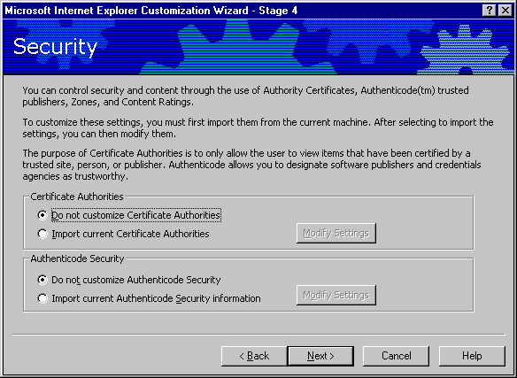
Option | Explanation
Certification Authorities | Click the appropriate option.  To modify settings, click Modify Settings.  To add a new root, click Add New Root.
Authenticode security | Click the appropriate option.  To modify settings, click Modify Settings.
Certification Authorities can be used to control sites where users can download certain content, such as ActiveX controls and Java applets. Site Authorities are a form of digital certificate for an Internet site. Using Authenticode technology, they indicate where programs come from and verify that they haven’t been altered.
These settings can be imported from the administrator’s computer to the users’ computers. Click Import current Certification Authorities and then click Modify Settings to modify the settings that will apply to users’ computers. Certificates can apply to network server authentication, network client authentication, secure e-mail authentication, and software publishing. For Windows 3.x, you can import and install up to 20 certification authorities. If you have more than 20 certification authorities on your computer, you'll need to identify the 20 certificates you plan to install, and then delete the rest while you prepare the Internet Explorer Administration Kit build.

You can then use Certificate Manager to view and manage your certification authorities information. Certificates can apply to network server authentication, network client authentication, secure e-mail authentication, and software publishing.
Administrators can also specify permission for users to download content only from specified sites. To do this, select the Only trust certificates from listed software publishers check box in Modify Settings.
You can use Authenticode to designate software publishers and credentials agencies as trustworthy. You can also import these settings from your computer. If you want to modify the settings that you will apply to your users' computers, click Import current Authenticode security information, and then click Modify Settings.
Authenticode allows administrators to designate software publishers and credentials agencies as trustworthy. These settings can also be imported from the administrator’s computer. Click Import current Authenticode information, and then click Modify Settings to modify the settings that will apply to users’ computers.

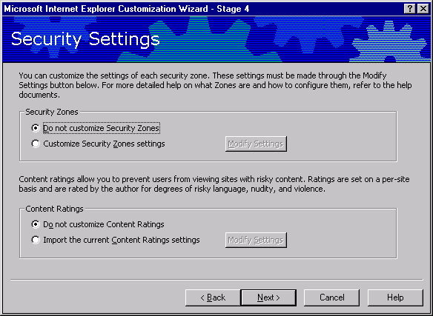
Security Settings

Administrators can manage security zones and content ratings for a company and customize the settings for each security zone. By using content ratings, administrators can prevent users from viewing content that may be considered offensive.
Option | Explanation
Security Zones | Click the appropriate option.  To modify settings, click Modify Settings.
Content Ratings | Click the appropriate option.  To modify settings, click Modify Settings.

Security Zones
If you want to modify the settings that will be installed on your users' computers, click Import the current security zone settings, and then click Modify Settings. In Stage 5, you can also specify whether users will be able to change their security settings.
Note that the following settings or sections do not apply to UNIX and 16-bit versions of the browser:
- UNIX versions of the browser
ActiveX controls and plug-ins
Font download
Software channel permissions
Launching applications and files
Installation of desktop items
- 16-bit versions of the browser
User authentication
Font download
Software channel permissions
Installation of desktop items
Active scripting
Launching applications and files from an IFrame

Content Ratings
Microsoft Internet Explorer provides a way to help you control the types of content that your computer can access on the Internet. You can adjust the settings to reflect what you think is appropriate content in four areas: language, nudity, sex, and violence.
If you want to modify the ratings that you will apply to your users' computers, click Import the current content ratings settings, and then click Modify Settings. You can then modify your settings by using Content Advisor.
You should know that:
- Content Advisor uses very cautious rating standards when you first enable it. You can adjust these settings to match your own preferences.
- Not all Internet content is rated. If you allow others to view unrated sites, some of those sites could contain inappropriate material.

Stage 5: Customizing Components
In this stage of the wizard, corporate administrators can customize the following:
- Your users' news and mail servers, if you're including Outlook Express in your customized package.
- IMAP e-mail server settings for your users, if you are deploying Outlook Express and have an IMAP server.
- Outlook Express custom content, if you want to add your own welcome e-mail message and customize the InfoPane that appears when users start the program.
- Outlook Express custom settings, if you want to provide assistance to users who need to obtain additional mail accounts or create a default message rules file for your users.
- Outlook Express user interface, if you want to determine whether the Folder bar, Folder list, MSN Messenger Contacts, Status bar, or Outlook bar, among other things, are displayed.
- Outlook Express compose settings, if you want to provide a corporate disclaimer or signature with Internet newsgroup or e-mail messages.
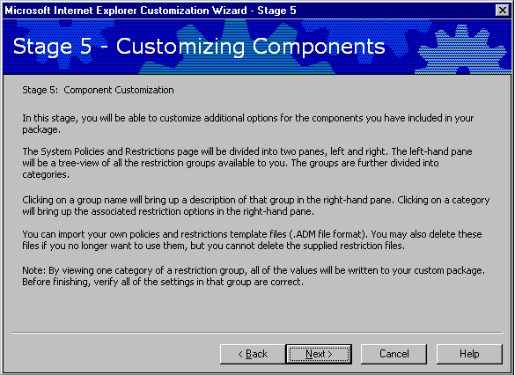
- Windows Address Book Directories, if you want to provide Internet directory services to your users and customize Lightweight Directory Access Protocol (LDAP) servers.
- System policies and settings, if you want to preset or control settings, including options for the browser, e-mail, security, and the desktop.

Programs
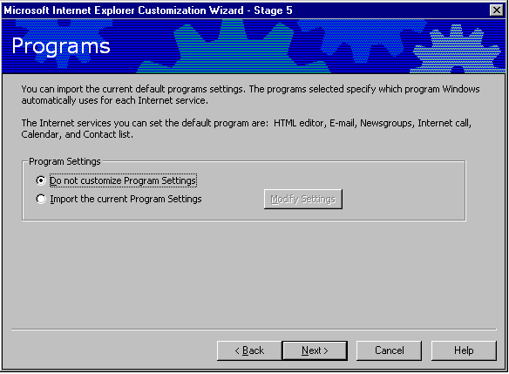
You can import your default program settings, such as which programs are the default for electronic mail and for editing HTML. These settings are located on the Programs tab of the Internet Options dialog box.
If you do not want to preset your user's settings, click Do not customize Program Settings. To import your settings without changing them, click Import the current Program Settings. To change your settings and then import them, click Import the current Program Settings, and then click Modify Settings.

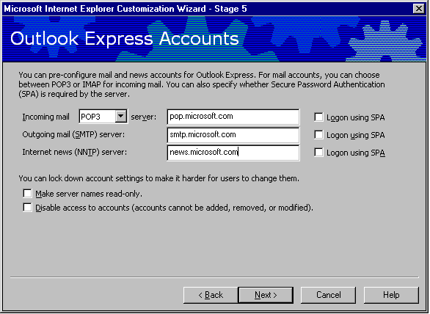
Outlook Express Accounts

These settings are available because you downloaded Outlook Express. You can specify the mail and news servers here and specify whether you will require users to log on using Secure Password Authentication (SPA) to access a server.
Select the protocol that your mail servers are running. You can choose POP3, used by most Internet subscribers for e-mail, or IMAP, used mainly by corporate users who want to read their e-mail from a remote location. POP3 servers allow access to a single inbox, while IMAP servers provide access to multiple server-side folders.
Option | Explanation
Incoming mail (POP or IMAP) mail server | Type the fully qualified server address in the text box (for example, pop01.microsoft.com). Then, click Log on using SPA (Secure Password Authentication) if your POP3 or IMAP server requires authentication via an SSPI provider such as NTLM.
Outgoing mail (SMTP) server | An SMTP server is the outgoing mail server. In some cases, the SMTP server may have the same name as your POP3 server (for example, smtp.microsoft.com). Type the fully qualified SMTP server address in the text box. Then, click Log on using SPA (Secure Password Authentication) if your SMTP server requires authentication via an SSPI provider such as NTLM.
Internet news (NNTP) server | The Network News Transfer Protocol (NNTP) is the protocol used to distribute network news messages to NNTP servers and to NNTP clients (news readers) on the Internet. Type the NNTP address in the text box (for example, nntp.microsoft.com). Then, click Log on using SPA (Secure Password Authentication) if your NNTP server requires authentication via an SSPI provider such as NTLM.

Accounts
You can use these options to lock down account settings for your users. When users set up their mail and news accounts, those accounts will be configured using the restrictions you specify here.
Make all preconfigured accounts read-only
Select this option to create account settings that can be viewed, but not modified, by users.
Prevent deletion of all preconfigured accounts
Select this option to prevent users from deleting accounts that you have preconfigured for them.
Prevent configuration of additional accounts for users with preconfigured accounts
Select this option to prevent users from creating accounts in addition to their preconfigured accounts. This option is recommended for corporate administrators only.

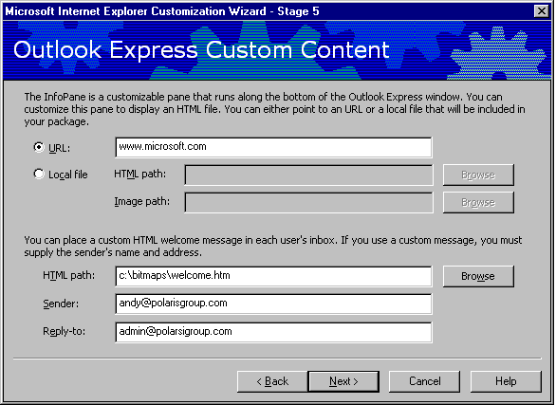
Outlook Express Custom Content

The Outlook Express InfoPane is where you can place helpful information and links, such as support numbers and frequently asked questions (FAQs). You can customize the InfoPane with an HTML file that is either a local file or an Internet address (URL). If you specify a local file, that file will be copied into your Internet Explorer Administration Kit distribution package and subsequently copied onto the user's computer during installation. The InfoPane does not appear as part of the Outlook Express user interface unless a URL or file is specified in the Internet Explorer Administration Kit.
Option | Explanation
URL | Click to specify a URL for the Outlook Express InfoPane.
Local file | If you did not type a URL in the previous text box, you can type the path to the local HTML file you want to use for the InfoPane, or click Browse to locate the file. If you specify a local file, you can also specify an image to be copied.
HTML path (custom welcome message) | The welcome message is an HTML file. You must also provide the sender's friendly name and the recipient's e-mail address. The Internet Explorer Administration Kit does not provide a way to add an image. However, if you edit the Welcome message outside of the Internet Explorer Administration Kit, you can add a link to an image from the Web.
HTML path (InfoPane) | Type the path to the InfoPane file or click Browse to locate it.
Sender | Type the name of the company or person sending the message (for example, Volcano Administration). This will appear on the From line of the message.
Reply-to | Type the e-mail address by which the user can reply to the message. Note that users can see this address in their welcome message, and they can reply to the welcome message.

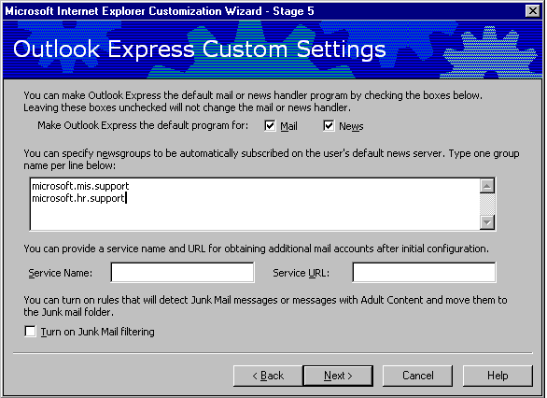
Outlook Express Custom Settings

Use this screen to create settings that will apply to all of your users. These defaults include setting a default mail and news client. Also, you can provide information that users need to obtain additional e-mail accounts. Finally, you can provide a default message rules file for your users.
Option | Explanation
Default messaging programs | If you want Outlook Express to start whenever a user clicks an e-mail link in Internet Explorer, select the Make Outlook Express the default mail program check box. If you want Outlook Express to start whenever a user clicks a news link in Internet Explorer, select the Make Outlook Express the default news program check box. The default mail client setting is also used by many programs when a user sends documents by e-mail. Note that this replaces any current default mail client that the user has specified.
Newsgroups | Use this box to type the names of one or more newsgroups that you want to subscribe your users to . For example, your ISP or organization may have several newsgroups that provide assistance and information to users.
New account source | You can add a menu item for users to request an additional mail account from your ISP. This entry is added to the New Account From menu in Outlook Express. Type the name of your ISP in the Service Name box (for example, Acme ISP). Then, type a URL in the Service URL box. When the user chooses this Service Name from the menu, the Web page is opened. An account number, which can be specified in the .ins file, and a unique identifier for the user will be sent to the ISP when the Web page is opened.
Junk mail filtering | Use this option to prevent junk mail messages or messages with adult content from filling up a user's Inbox. The messages that are detected are moved to the Junk Mail folder.

Outlook Express View Settings
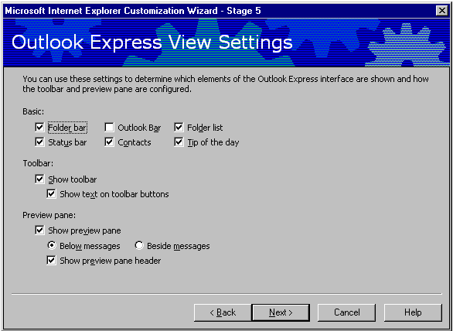
You can customize certain views that determine whether specific elements of Outlook Express are displayed and how they are displayed.
Option |  | Explanation
Basic | You can use these settings to determine which elements of the Outlook Express interface are included in the default view for new users.  - To include the Folder bar as a default for users, select the Folder bar check box.  - To include a list of e-mail and news folders, select the Folder list check box.  - To list the users' MSN™ Messenger Service contacts (if MSN Messenger Service is installed and configured) as well as addresses of e-mail correspondents, select the Contacts check box.  - To display a tip every time Outlook Express is started, select the Tip of the Day check box.  - To display the status bar, select the Status Bar check box.  - To display the Outlook Bar, select the Outlook Bar check box.
Toolbar | You can choose whether you want users to see the toolbar and whether you want to include text on it. The toolbar appears at the top of the Outlook Express window.
Preview pane | The preview pane can either be a horizontal pane located below the list of messages or a vertical pane located beside and to the right of the list of messages. The preview pane includes a preview pane header area that can be used to display message header information, including the From, To, Cc, and Subject lines of the message.

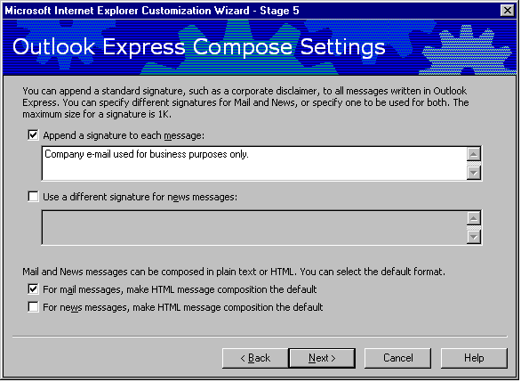
Outlook Express Compose Settings

Signatures
You can include a default signature, such as a corporate disclaimer, that will appear in Outlook Express newsgroup or e-mail messages. A disclaimer is often used to show that messages submitted by employees over the Internet do not represent official company policies. The maximum size of the signature is 1 KB.
You can append signatures only to newsgroup messages, only to e-mail messages, or to both types of messages.
HTML vs. plain text for mail and news messages
By default, e-mail messages are composed in HTML and news postings are composed in plain text. You can choose to override these settings. For example, in an environment where bandwidth is limited or many users have simple mail programs that cannot understand HTML, changing the default to plain text may make sense.
Likewise, in a corporate environment where all users use an HTML-aware newsreader, changing the news post default to HTML may be advisable.

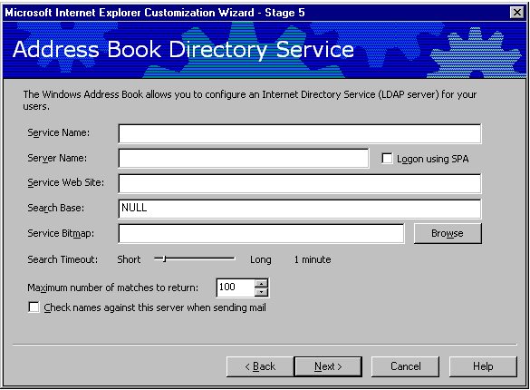
Address Book Directory Service

Directory services are powerful search tools that help users find people and businesses around the world. The Address Book supports LDAP (Lightweight Directory Access Protocol) for accessing directory services, and it comes with built-in access to several popular directory services. Administrators can specify the LDAP services for users.
Option | Explanation
Service Name | Type the friendly name of your LDAP service. This is the name that will be displayed to your users.
Server Name | Type the name of the directory service you want to add, such as ldap.AcmeISP.com or ldap.switchboard.com. If you require authentication via an SSPI package such as NTLM for users who access these services, click the Logon using SPA check box. Basic authentication using a user name and password combination can be configured via .ins files.
Service Web Site | This is the directory service's home page that appears when the user clicks the Start button, points to Find, clicks People, and then clicks Web Site.
Search Base | Sometimes known as the root or scope, the Search Base is the hierarchical level at which to search a given LDAP server. The search base can be a country, organization, or other type of grouping. The Outlook Express default for search base when none is specified is "c=us." To specify no search base, type NULL.
Service Bitmap | You can specify a custom 134 x 38 pixel, 16-color .bmp file. To ensure consistent color mapping, it is highly recommended that you use only the Windows 16-bit color palette when composing the bitmap. To locate the .bmp file on your computer, click Browse.

Search timeout | You can specify how long your users will wait before you time out a search request. Use the slider to set a time value between 30 seconds and 5 minutes.
Maximum number of matches to return | You can control the maximum number of results that can be returned to your users. Type the number in this box.
Check names against this server when sending mail | To have Outlook Express resolve names against the server when a user sends a message, select Check names against this server when sending mail. This setting instructs Outlook Express to look up e-mail addresses for names typed on the To, Cc, and Bcc lines of a mail message.

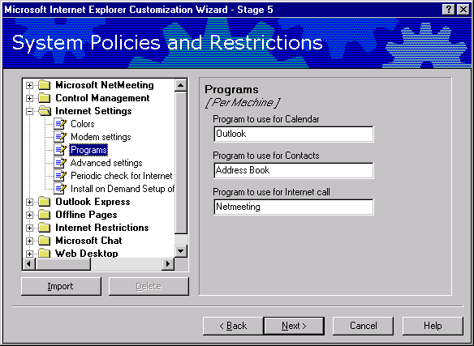
System Policies and Restrictions

Corporate administrators can customize and restrict numerous settings, ranging from whether users can delete printers to whether they can add items to their desktops. For more information, see the Managing Users section in this document.

Option | Explanation
Left Pane | Select the subject to change policies and restrictions for.
Right Pane | Specify the policies and restrictions for the subject.

You should understand the impact of the security settings on your users, especially if you have roaming users who share computers with other users. For more information, see the note below.

To set system policies and restrictions

1. Double-click each category to display the options.

2. Select or clear the check boxes you want.

Notes
- The settings displayed in the wizard are contained in administration (.adm) files that come with the Internet Explorer Administration Kit. If you are familiar with .adm files, you can use the wizard to set the policies and restrictions you have set up in your own .adm files by clicking Import.
- If you remove the Run command from the Start menu setting for the Web Desktop, the initial start page (Start.htm) on a CD installation will not work properly.
- To ensure that the Trusted Publishers setting for the Security section of Internet Restrictions is effective, you should verify that security zones and policies are correctly set up.
User settings can be stored in a central location so users can access them from any computer they log on to.. This could be useful, for example, for a user who needs low security settings but who uses a computer that is typically operated by someone with restrictive security settings. .

Customizing security settings
You can allow three typical levels of customization for security settings:
- Control, or "lock down," all settings.
To lock down all settings

1. Click Internet Restrictions, and then click Security.

2. Select the Use only machine settings for security zones check box.
- Control user settings while allowing profiles for roaming users to be downloaded.
You can specify that settings can't be changed, without locking out roaming users who have different profiles. The Windows roaming user feature allows users to download their settings from a server.
To restrict a user from changing policies for a zone
- Click Internet Restrictions, and then click Security.
- Select the Do not allow users to change policies for any security zone check box.
To restrict a user from adding or deleting sites
- Click Internet Restrictions, and then click Security.
- Select the Do not allow users to add/delete sites from a security zone check box.
- Customize initial settings, but allow user to modify them.
In this stage of the wizard, you can customize many user settings, including security levels and ratings. Customizing the settings in this stage doesn't determine whether the user can control the settings.

Wizard Complete
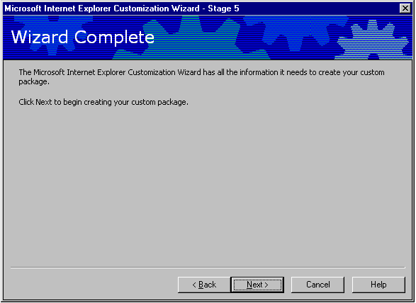
After you click Finish, the wizard builds your custom browser package. In most cases, your next step will be preparing your files for downloading from the Web, and then preparing other media (such as compact discs) for distribution.
Programs and cabinet files distributed via the Internet, or an intranet that isn't configured, for users of 32-bit operating systems must be digitally signed. Digital signatures show where programs come from and verify that programs haven't been altered. If you specified that the Internet Explorer Customization wizard will sign your programs and custom files, then the wizard will sign your programs as it builds your package. If you did not specify that the wizard sign your programs and files, then you need to sign them before users download them.
Unlike Internet Explorer 32-bit versions of the browser, 16-bit and UNIX versions of the browser do not perform digital signature verification. Programs or cabinet files for these operating systems do not need to be signed.
Note: If you are using the Internet Explorer Administration Kit in demo mode, you will not be able to proceed to browser distribution.

Stage 6: Browser Distribution
The Internet Explorer Administration Kit generates several installation subdirectories in the c:\builds folder. The explorer view of the generated packages should be similar to this:
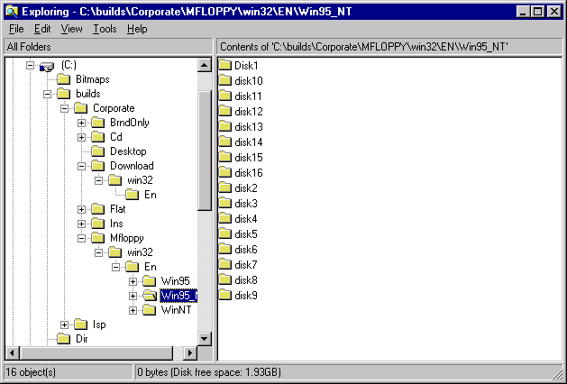
Explorer view of the generated package.

Web Distribution
The following outlines how Internet Explorer 5 Setup works for users:
- IE5setup.exe extracts the setup files into a temporary directory.
- IE5setup looks at the [String] section of IE5setup.inf for the URL location of the IE5sites.dat file.
- Setup goes to the file IE5site.dat to retrieve the URLs for the download sites and then displays the download sites to the user.
- Setup downloads .cab files, which are placed in the directory the end-user specifies.
- Setup extracts the .cab files.
- Setup installs Internet Explorer and each component the administrator specified.
- If necessary, Setup prompts the user to restart the computer.
The important files for a Web distribution of Internet Explorer 5 is the file iesetup.exe, the contents of the Download subdirectory, and the file IE5sites.dat. The file Ie5setup.exe locates the URL path to IE5sites.dat. IE5sites.dat is a text file that lists all of the download location information and the path to the .cab files in each location. For the purposes of this guide, it is assumed that administrators are running a Microsoft IIS or Personal Web Server, and that the default Web share location is c:\inetpub\wwwroot. If a different server or path is being used, some of the following locations may need to be changed.

IE5Setup.exe
The IE5Setup.exe file is a small (400K) file that can be distributed by e-mail or floppy disk. IE5Setup.exe is created in the following path: c:\builds\<Build_Number>\Download\Win32\En.

Download Subdirectory
The Download subdirectory needs to be copied onto the Web server in a specific location. You can specify the Download subdirectory at the beginning of the Internet Explorer Customization wizard, or copy it to the Web server after the package is created. The Web locations were specified during the Internet Explorer Administration Kit package creation. Administrators should make a note of the location that was specified as the download path for each download location in the Internet Explorer Administration Kit package. Earlier in the Customization wizard Walkthrough in this guide, this path was specified as http:\\www.acmecorp.com\ie5\. The Download folder needs to be copied to a location specified during the Customization wizard. The file path in this example might be c:\inetpub\wwwroot\ie5, because this is the path specified in the file ie5sites.dat. This folder structure can be created simply by creating a folder in the administrator’s Web root (in this example, “Internet Explorer 5”), then copying the entire Download folder created under c:\builds\<build_number> to this new folder. In this example, the folder is named Internet Explorer 5 and all content has been moved into it, giving the URL path of http://www.acmecorp.com/ie5.
Note: The c:\builds\<build_number> path will also contain the CD and floppy installation packages if these were created in the Internet Explorer Administration Kit; they do not need to be copied to the Web Server.

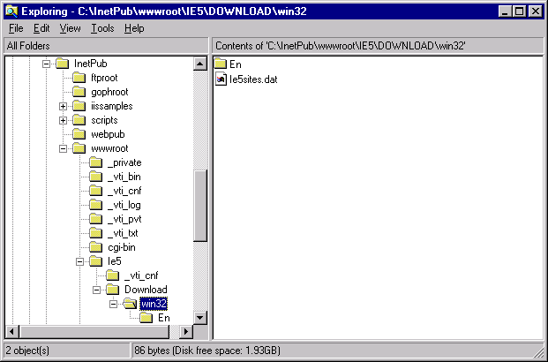
Explorer view of the Web download folder copied to the Web share location.

The IE5sites.dat File
IE5sites.dat is a text file that contains the path to the cabinet files for each download site specified during the Internet Explorer Administration Kit package creation process. The IE5sites.dat file will be put in the correct place by copying the entire Downloads subdirectory to the path specified in the Customization wizard.

CD Distribution
Copy everything from within the c:\builds\<build_number>\CD subdirectory onto the root of the CD. Unlike a Web distribution, the CD subdirectory itself is not copied. The root of the CD-ROM will contain the Win32 subdirectory, Autorun.inf, and a setup file.

Multiple Floppy Distribution
The Internet Explorer Administration Kit will create a subdirectory called \mfloppy. Within this subdirectory are version-specific package folders, and within these are individual disk folders. Copy the files within each folder to the root of each disk.

LAN Distribution
The Internet Explorer Administration Kit will create a \Flat subdirectory within the \builds folder. This subdirectory contains all the installation files in a single folder that can then be easily copied to a network share. The advantage of using the flat LAN installation is that it is simpler to distribute than a Web installation.

Managing Users: Internet Explorer Administration Kit Profile Manager
The Internet Explorer Administration Kit Profile Manager can be used to create and maintain the automatic configuration files. With the Profile Manager, administrators can specify a wide range of browser, user, desktop, and system settings and restrictions. The Internet Explorer Administration Kit Profile Manager is used to maintain Internet Explorer 5 policies over time.
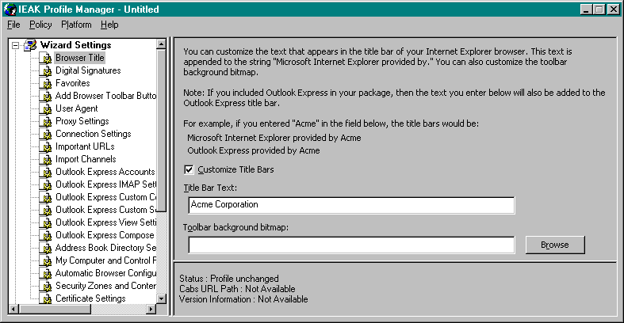
Sets of Policies and Restrictions are saved as an .ins file. These .ins files are created into two places for each package during the Internet Explorer Administration Kit Customization wizard. The first location is in the INS subdirectory, for instance, “c:\builds\Corporate\INS\Win32\En\Install.ins." The other location is the CD subdirectory. Different .ins files can be created to reflect different administration and configuration requirements for an organization. Different packages can be created to distribute to each group in an organization, or the .ins file can be manually specified on the browser.
The Profile Manager is organized into a left-hand pane showing a hierarchical tree of objects and a right-hand pane showing the options. After creating a new .ins file or opening one of the install.ins files created by the Internet Explorer Administration Kit, an object in the tree in the left-hand pane is selected and the options and settings for that object appear in the right-hand pane. Administrators can change options or specify settings as necessary to manage automatic browser configurations.
The Internet Explorer Administration Kit Profile Manger provides two categories of settings that can be specified: Wizard Settings and System Policies and Restrictions.

How Profile Manager Works
The Internet Explorer Administration Kit Profile Manager creates and edits instruction (.ins) files. These .ins files are then specified in the browser under View/Internet Options/Connections/Automatic Configuration. The .ins files can be locally stored, i.e., c:\config.ins, or they can be stored in a Web location, such as http://www.acmecorp.com/ie5/config/autoconfig.ins. The .ins file gets checked either at a specified interval, such as every 720 minutes, or every time the browser is started if no interval is specified.
Because the location of this file will have to be specified before it is actually created, it is a good idea to plan out the name(s) of the configuration files and their locations in advance. The Internet Explorer Administration Kit lets administrators pre-configure browsers with the URL of an .ins file, but this file is not created during the Internet Explorer Administration Kit process. A default install.ins file is created in the path c:\builds\<build_number>, but this file should be edited and renamed before distribution. As mentioned in earlier sections, it is a good idea to rename .ins files, as the Internet Explorer Administration Kit creates numerous instances of install.ins. Edits made to these files can easily get lost or confused unless the file is renamed. When the .ins file is edited, .cab files may also be created that will need to get copied to the Web distribution location.

Changing Wizard Settings
In the left-hand pane, the Wizard Settings object and its sub-objects correspond to settings that can also be specified using the Internet Explorer Administration Kit Customization wizard. An object can be selected and the corresponding options and settings can be changed. For example, the Browser Title object and Browser Title bar and Toolbar background bitmap options can be selected and changed.

Changing System Policies and Restrictions
In the left-hand pane, the Systems Policies and Restrictions object and its sub-objects correspond to the same settings available on the Internet Explorer Administration Kit Customization wizard System Policies and Restrictions page. Administrators can select an object and change the corresponding policies and restrictions. For example, the Web Desktop tree can be expanded, and the Desktop object can be selected to specify Desktop options such as Do not allow changes to Active Desktop.
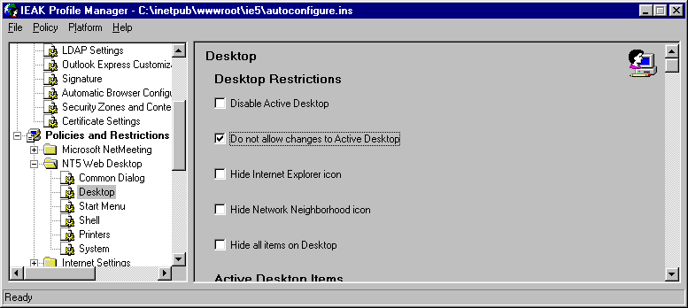
The System Policies and Restrictions folder contains nine default policy template (.adm) files to specify policies and restrictions. These are saved to information (.inf) files, which are packaged into the automatic configuration companion cabinet (.cab) files for download to a user’s system. When unpacked, the .inf files are used to change policies and restrictions on users’ systems.
The first time either the Internet Explorer Administration Kit Profile Manager or the Internet Explorer Administration Kit Customization wizard is run, it creates the nine default policy template (.adm) files in the C:\Program Files\Ieak\Policies directory. When changes are saved to system policies and restrictions, the Internet Explorer Administration Kit Policy Manager saves the changes to the .inf files and packages them in cabinet (.cab) files. The two possible cabinet files are branding.cab and desktop.cab. If these .cab files are created, then they need to be copied to the Web distribution point where the automatic configuration .ins file resides.
Administrators can specify desktop, shell, and security settings across an organization. Numerous settings can be customized, ranging from whether users can delete printers to whether they can add items to the Windows Desktop Update.
Administrators can control or “lock down” features and functions. For example, use the System options under the Shell category to prevent Windows 95 users from restarting their systems in MS-DOS® mode, or use the Security option under Internet Properties to prevent users from changing any of the security settings on the Security property page in Internet Explorer. When features are locked down, they either don’t appear or they appear in gray type on the user’s desktop.
Before changing system policies and restrictions, administrators should understand the impact of the security settings on users, especially if roaming users will be sharing computers with other users. Consider for example, the implications of removing icons from the desktop, or not allowing users to change their security settings. These policies should be clearly communicated to the users before deploying any changes to the organization.

Using Custom Policy Templates
Administrators familiar with Windows policy template (.adm) files can create their own templates to define additional restrictions. Policies and restrictions, and policy template (.adm) files are a standard feature of Windows 95 and Windows NT operating systems. For more information, see the Windows documentation.
Administrators can choose Import on the Policy menu to import custom policy template (.adm) files. Choose Check Duplicate Keys on the Policy menu to check for duplicate registry keys in the templates and to delete any duplicates from the templates. Always test templates thoroughly in the lab before using them to make changes to users' systems.
When administrators use custom policy templates, the Internet Explorer Administration Kit Profile Manager generates an .inf file using the file prefix for the imported custom template. For example, when custom.adm is imported, a custom.inf file will be generated and added to the companion .cab files.

Maintaining Automatic Configuration Files
During the installation wizard, an Install.ins file was created in the c:\builds\<build_number>\Ins\Win32\En subdirectory. This file needs to be copied to the location specified during the Customization wizard and renamed to the name specified in the CW. In this example, the file was renamed to autoconfig.ins and copied to the path c:\inetpub\wwwroot\ie5\config.
To maintain automatic configuration files, administrators can open the .ins file in the Profile Manager, change settings, and save the .ins file. The Profile Manager keeps the companion files current each time the .ins file is saved.
Caution: Files should not be maintained on the production server. Administrators should copy the .ins file) and their companion files from the production location (such as c:\inetpub\wwwroot\ie5 to a working directory, modify the files as necessary, and test automatic configuration in a lab to verify that automatic configuration changes work as intended. After changes have been validated, update the automatic configuration files on the production server.

Setting Up Automatic Configuration in Previously Deployed Browsers
Clearly it is advantageous to use the Internet Explorer Administration Kit to customize Internet Explorer 5 so that automatic configuration is enabled before the browser is deployed. If that is not possible, users will have to perform a simple task to enable automatic configuration. Once these steps are performed, the Internet Explorer Administration Kit Profile Manager can be used to lock these settings down so users will not be able to change them.
To set up Internet Explorer 5 for automatic configuration, users need to do the following:
- From the Internet Explorer window, choose Internet Options on the View menu.
- Select the Connections property page, then select a connection (such as LAN or a Dial-up).
- Select either LAN Settings or Settings.
- Type the URL automatic configuration file name in the Autoconfiguration URL section.
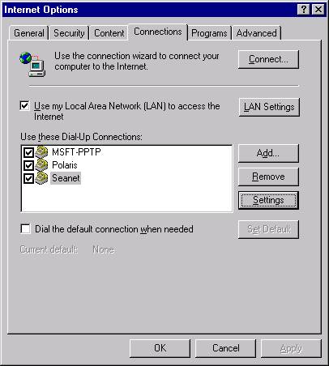
Connections configuration tab in Internet Explorer.
Note: Some automatic configuration changes require the system to be restarted before changes to the system registry will take effect.

Appendix B: Enabling Connections with the Connection Manager Administration Kit
Use this Connection Manager Administration Kit Guide to plan and develop the Connection Manager custom elements that you want in your client dialer. Then run the Connection Manager Administration Kit (CMAK) wizard, answering the questions and providing the information about your custom elements. The CMAK wizard then builds a service profile, which is a set of files you distribute to your users so that they can easily install and run your custom version of Connection Manager.
The Connection Manager Administration Kit Guide is designed for the network administrators, information officers, and other team members responsible for the design, development, testing, distribution, and support of connection software for the customers who connect to your Internet or network service. More discussion on Automatic Connections is included in Appendix D.
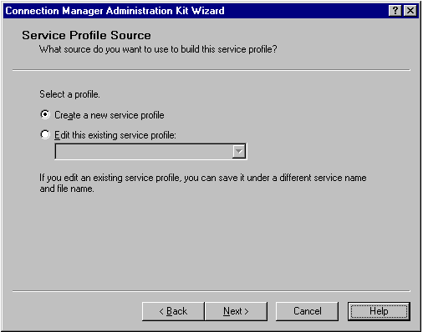

Service Profile Source

Each time you run the Connection Manager Administration Kit (CMAK) wizard, you create a service profile. You can create as many profiles as needed to support each specific target audience. After creating an initial profile, you can use the CMAK wizard to edit it. You can save the edited profile under the same name to overwrite the existing profile, or you can specify a different service name and file name to save it as a separate profile and preserve the existing file.
Notes
- To create a service profile for Intel systems, use the Intel version of the CMAK wizard on an Intel operating system. To create a service profile for Alpha systems, use the Alpha version on an Alpha system.
- To create a service profile for another national language, use the version of the operating system and the CMAK wizard that are appropriate for the language.
- When you edit a service profile created using a previous version of Connection Manager, the CMAK wizard automatically upgrades the profiles to Connection Manager 1.2. Any changes you have made manually to the .inf file (using advanced customization techniques) will not be retained in the upgraded file. However, the CMAK wizard creates a backup of the old .inf file before creating the updated file.
- If you change the file name, be sure to change the service name also. If a user installs two service profiles with the same service name but different file names, the service profiles do not work correctly.
Each service profile should be specific to an audience. For example, you might set up separate profiles if:
- You want to make each service profile specific to a single operating system.
- You specify phone books to support each of your distinct geographic areas or corporate organizations.
- Different users require different connection methods (dial-up versus direct).
- You need to support VPN connections only for specific users.
- The individual corporations or groups you support each want to use their own logos or other proprietary symbols or text.
- The help desk or other support is not the same for everyone and you want to provide specific information to each user group.
- You want to establish different administrative authorities for the groups you support.
Note
- To simplify administration of multiple service profiles, you can merge existing profiles into a parent service profile.
You must run the CMAK wizard again for each service profile you want to create, including each service name or file name you want to present to your users.
It is easier to create additional service profiles if you edit an existing profile and then change the service name and file name.
When you create a service profile, the CMAK wizard copies all files that are incorporated in the profile into a \Program Files\CMAK\Profiles\ServiceProfileFileName folder. When you edit existing profiles, the CMAK wizard always pulls the incorporated files from the ...ServiceProfileFileName folder. To make changes to the incorporated files, edit the incorporated file in the ...ServiceProfileFileName folder and then run the CMAK wizard again to update the service profile. Or, if you edit the file that is not in the ...ServiceProfileFileName folder, start the CMAK wizard, add the updated file (by browsing to find it), and then finish running the wizard.
Note Connection Manager supports user installation of multiple service profiles, running multiple instances of Connection Manager, and multiple user profiles for each service profile. If a user installs more than one service profile, each is installed in a separate folder. You can provide as many profiles to your users as necessary to support your service, but each must have a different service name and file name.

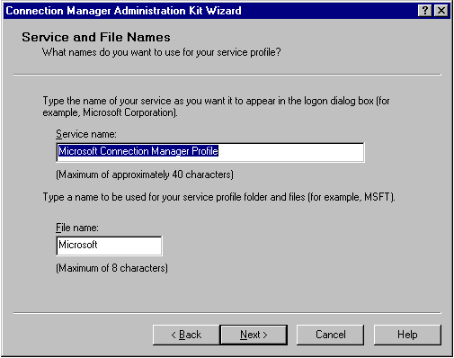
Service and File Names

You must specify a service name and a file name in the CMAK wizard to identify your service profile.

Service name
The service name identifies your service to the users. Connection Manager can display only the 31 to 45 characters (depending on the characters and capitalization used). This name appears at several points when the user runs your service:
- In the title bar text for the logon dialog box for your service.
- In dialog boxes that appear during installation of Connection Manager and the service profile.
- As the desktop icon name for your service.
- On the program button that appears on the taskbar when the program is running.
- In the ToolTip that appears when the mouse points to the status-area icon, which is located at the far right of the task bar.
- Within the service profile files, for entries such as the default Dial-Up Networking entry.
This name is often a company or other business name. For example, the fictitious company Awesome Computers, which we use in this guideline for many of our examples, might specify "Awesome Computers" as the service name. Or, if Awesome Computers wanted to set up separate service profiles for each department, the service name for one of them might be "Awesome Computers - Marketing."

File name
The file name is the name given to the files created by the CMAK wizard when building the service profile. The file name can be up to 8 alphanumeric characters, with the following limitations:
- Do not use any of the following:
! , ; <space> * = / \ : ? ' " < >
- Do not use extended character sets in a file name. A file name created with extended character sets (such as those containing ü, é, and other extended characters) might not be properly installed.
Notes
- Make sure that the service and file names are different from all other service and file names that you provide to your customers. If two service profiles on the same computer have the same service or file name, the associated connection icons do not work correctly.
- When editing an existing profile, if you do not want to write over the existing service profile, you must change the file name.
The file name is used for the following files created by the CMAK wizard, including:
- The folder containing the files needed to install Connection Manager and the service profile, located at \Program Files\CMAK\Profiles\ServiceProfileFileName.
- The self-extracting executable (.exe) file.
- The .cms file, which contains the configuration data for Connection Manager features, such as the names of the phone book and connection methods.
- The .cmp file, which stores user-specified information, such as the name of the .cms file to be used.
- The .inf file, which is used for the setup and installation of Connection Manager on the user's computer.
- The .sed file, which specifies the contents of the .cab file and how to compress the files when the service profile is built.
The file name for the service profile is also used for the folder created on the user's computer when the .exe file is run.

Merged Services Profile
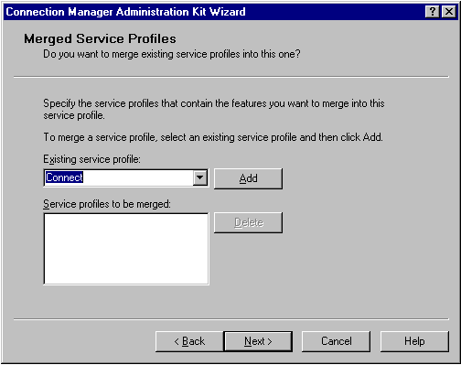
If you have information in service profiles that you need in the service profile you are currently building, you can use the CMAK wizard to merge much of the information from existing profiles into the new profile. A profile that contains information from other service profiles is called the referencing profile. A service profile that has its information merged into another service profile is called a merged profile.
For instance, you would incorporate several phone books in a single service or file by merging existing service profiles containing the other phone books.

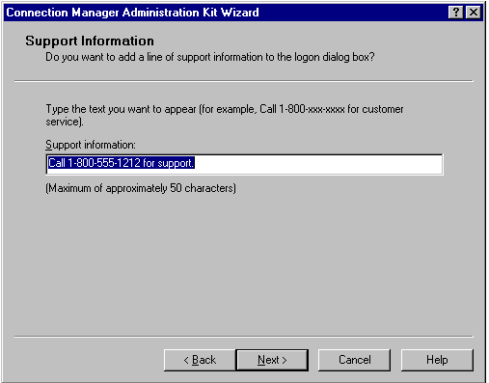
Support Information

Using the CMAK wizard, you can specify a line of information to be displayed in the logon dialog box, directly above Connection status. This line of text can be a maximum of approximately 50 characters and usually gives users a number to call for support (for example, "Call 1-800-xxx-xxxx for customer service."). No default text exists for this option. If you do not specify a line of text, this area of the logon dialog box will be left blank.

Realm Name
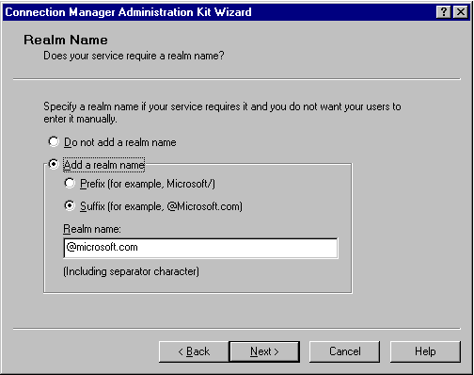
Realm names are used for network routing and authentication. They provide the identification necessary to forward authentication requests to the server that holds the user's credentials.
Using the CMAK wizard, you can specify a realm name prefix (such as Awesome/) or suffix (such as @Awesome) to be added to the user name that a person enters when connecting to your service. The realm name includes any separator characters, such as @ or /. If you specify the realm, users do not have to provide it themselves because Connection Manager automatically places the realm name before or after the user's name.
If your service uses multiple networks or ISPs for access, you need to provide different realm information for each one. To do this, create service profiles for each of the networks and then merge them together in a referencing profile.

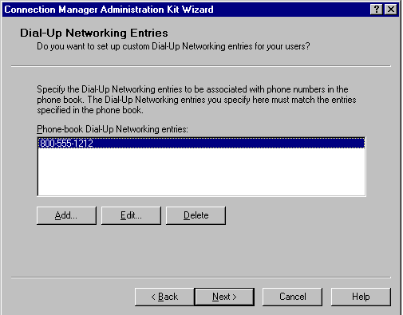
Dial-Up Networking Entries

Dial-Up Networking entries are specified in the Phone Book Administrator of Connection Point Services so you can customize how specific Points of Presence (POPs) are accessed. Use the CMAK wizard to specify the custom properties for the Dial-Up Networking entries.
Customizing how Dial-Up Networking entries are handled can provide more effective handling of unique network authentication or routing requirements for POPs in your phone book. For each Dial-Up Networking entry, you can specify the DNS or WINS addresses to use with POPs associated with that entry and, if you want, a script.
Before you run the CMAK wizard, you must decide which Dial-Up Networking entries you want to customize and the options to use for each. Use the planning worksheet to document your requirements, which is available in the CMAK Help.

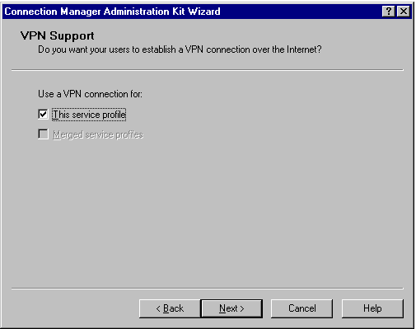
VPN Support

Virtual Private Network (VPN) connections provide remote access to private networks over the Internet (or other network). A VPN connection establishes a tunnel through the Internet to the private network to provide a more secure connection than available through a standard connection. To create a VPN connection, users can either dial into a local Internet service provider (ISP) or use a pre-existing connection (direct connection).
This means that remote users can connect using worldwide Internet access points to access firewall-protected servers as easily as local users. For corporations, it means that employees have remote access over the Internet to their corporate private networks, usually through a local phone number.

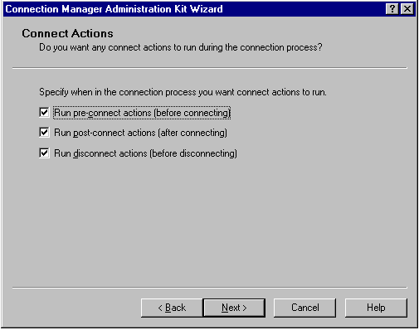
Connect Actions

To set up the service profile so that programs or install software automatically starts when a user connects to the service, administrators must correctly specify the connect-action programs when running the CMAK wizard. These actions, especially post-connect actions, should not be confused with auto-applications. A separate wizard screen is provided for running applications automatically after connection.
- Pre-connect actions run immediately after the user selects “connect,” but before any connection actually takes place.
- Post-connect actions run after establishing the dial-up networking connection. Some post connect actions, such as automatically updating phone book entries and using MCIS logon information, have been preconfigured into the post-connect dialog box that follows.
- Disconnect actions run immediately after disconnecting.

Pre-Connect Actions
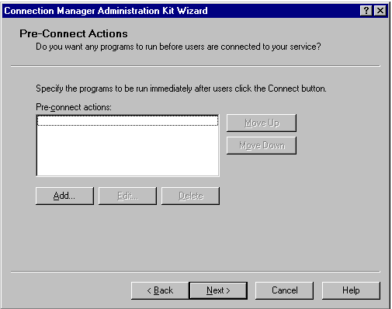
As soon as users click Connect, Connection Manager runs the pre-connect actions you have specified in your service profile. These are run before Connection Manager establishes a connection to your service.
You cannot set up a pre-connect action that requires an interaction with your service. If interaction is required for part of the action, split the action into a pre-connect action and either a pre-tunnel or post-connect action, depending on the interaction requirements.

Post-Connect Actions
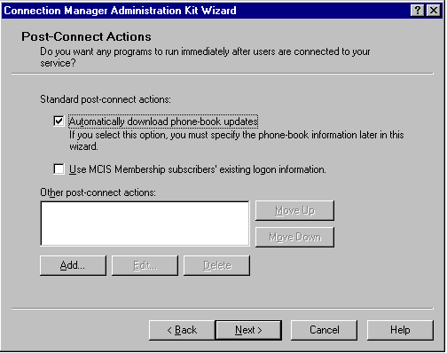
Connection Manager runs post-connect actions after establishing a connection or, if using a VPN connection, after establishing the tunnel.
In the CMAK wizard Post-Connect Actions dialog box, in addition to the custom post-connect actions that you specify, you can specify that Connection Manager run two standard post-connect actions, both of which run regardless of the connection type.

Disconnect Actions

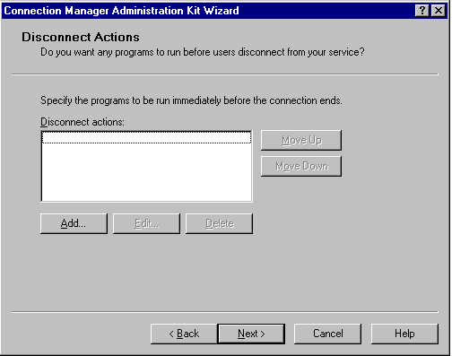
Connection Manager runs disconnect actions immediately before disconnecting from your service. You can use a disconnect action for routine administration. For example, you might set up a disconnect action to collect status information from your service, such as total minutes online (if this information is tracked by your service). This information can then be displayed for the user.

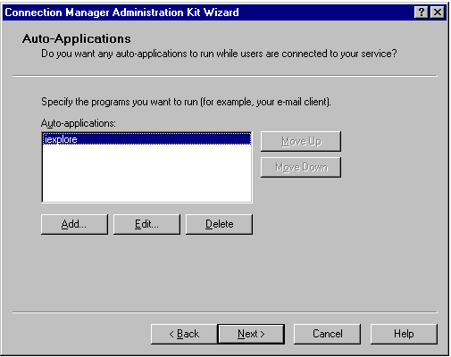
Auto-Applications

Connection Manager runs auto-applications after establishing a connection and, for a VPN connection, after establishing the tunnel. Each auto-application that you specify in the CMAK wizard runs every time the user connects to your service, whether the connection is a dial-up connection or a direct connection.

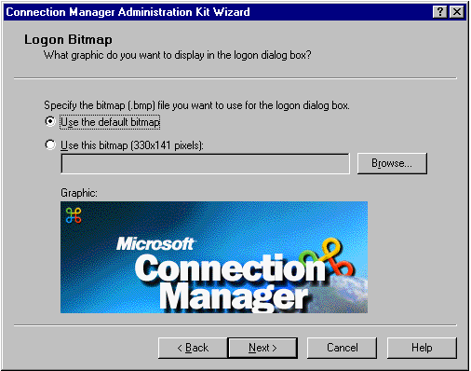
Logon Bitmap

You must specify in the CMAK wizard whether to use the Connection Manager default bitmaps or your own graphics. You can customize the user interface to include your company logo or another image that identifies your organization. You can replace the graphics in both the logon dialog box and the Phone Book dialog box with a bitmap (.bmp) file.
This screen allows administrators to use the default logon bitmap or to specify one. The bitmap must be 256 colors, 330 x 131 pixels.

Phone Book Bitmap
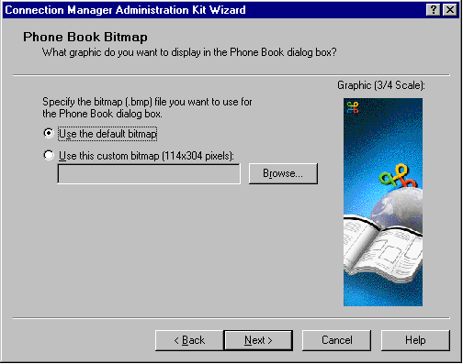
You must specify in the CMAK wizard whether to use the Connection Manager default bitmaps or your own graphics. You can customize the user interface to include your company logo or another image that identifies your organization. You can replace the graphics in both the logon dialog box and the Phone Book dialog box with a bitmap (.bmp) file.
The Phonebook Bitmap is a 114 x 304 pixel bitmap that appears on the left side of the Phone Book dialog box. If no bitmap is specified, then the default bitmap will be used.

Phone Book
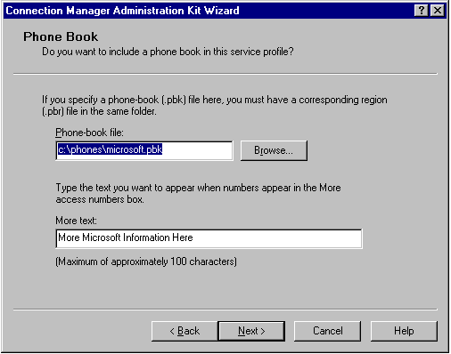
Connection Point Services provides support for creating, maintaining, and updating phone books. You can also create your own phone book (without Connection Point Services), but the complexity of the format and requirements makes this difficult if you have more than a single Point of Presence (POP).

Icons

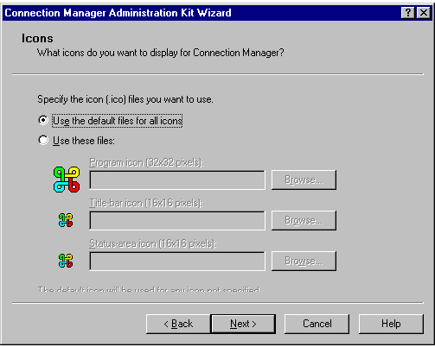
You use the CMAK wizard to specify the three icons your users see.
- The large program icon is used as the desktop icon. It also appears in the ALT+TAB switch window and in several other pop-up dialog boxes. This icon is 32 × 32 pixels.
- The small title-bar icon appears at the left edge of the title bar in the logon dialog box, in various pop-up dialog boxes and, when the program is running, on its program button on the taskbar. This icon is 16 × 16 pixels.
- After a connection is established, the small status-area icon appears in the status area at the far right of the taskbar. This icon is 16 × 16 pixels.
Connection Manager contains default images for these three icons. If you prefer to use your own icons in place of the default icons, you can use an icon-editing program to create them. All of these must be 16-color icons. Consider creating similar icons to unify the appearance of the service profile. To ensure that your icons appear correctly, create icons that match the size and overall shape of the default icons.
Note: These files are icon (.ico) files and not bitmap (.bmp) files. If no custom icons are specified, then the default icons will be used.

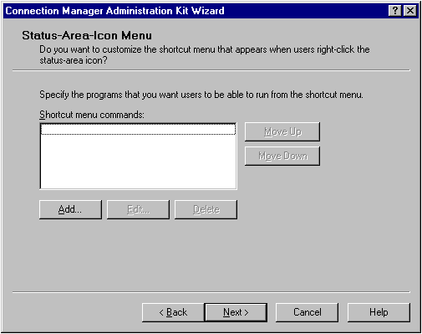
Status-Area-Icon Menu

The status-area icon appears in the status area of the taskbar when the user is connected to your service. The status-area-icon menu appears when a user right-clicks this status-area icon. This menu provides users with a shortcut to specific programs. The default commands appearing on the menu are Status and Disconnect. You use the CMAK wizard to customize the shortcut menu by specifying which, if any, additional commands will appear on the menu.

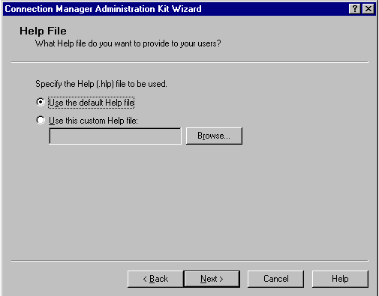
Help File

The administrator can specify a custom Help file or use the default Connection Manager Help file.

Connection Manger Software
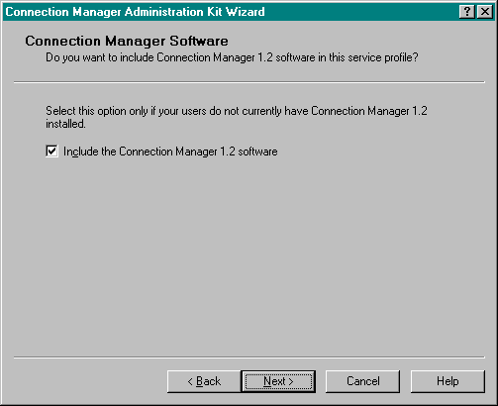
To run a Connection Manager 1.2 service profile, users must install Connection Manager 1.2 . If the organization's users do not already have it installed, include the software in your service profile. In the CMAK wizard, you can include Connection Manager in the service profile being built, so it will be installed when the user installs the service profile. If you include Connection Manager 1.2 in a service profile and the user already has a previous version of Connection Manager installed, Connection Manager will automatically be upgraded at installation. Connection Manager cannot be installed if the current or a newer version is already installed on the user's computer. The service profile will be installed, if the Connection Manager software included in the profile does not install.

License Agreement
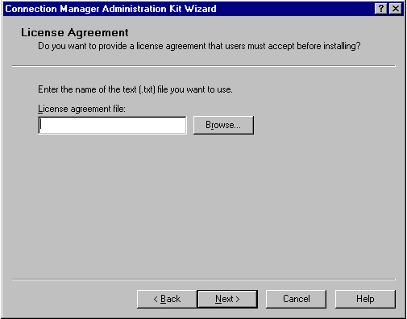
You can include your own license agreement with your service profile. This license agreement appears when the user clicks OK to begin installing your service profile. If the user accepts the license agreement, installation continues. If not, installation is cancelled.
Use a text-editor program such as Notepad to create your license agreement as a text (.txt) file. To avoid formatting problems, do not use hard returns (forced line breaks) at the end of lines. Line-wrapping for the license agreement is done automatically when the service profile is built.

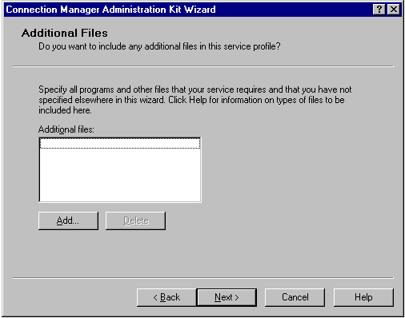
Additional Files

You can include additional files with your service profile to help your users implement your service. All files needed for your service that are not specified elsewhere in the CMAK wizard should be specified in the Additional Files dialog box. This section contains information on files that you might want to include as Additional Files.

Connect action and auto-application files
If you create a connect action, include the program for the connect action by specifying it in the Add/Edit Connect Actions dialog box. However, you can specify only one program there for each connect action. You must specify any other files required to implement the connect action as Additional Files. The same is true for auto-applications.

Ready to Build the Service Profile
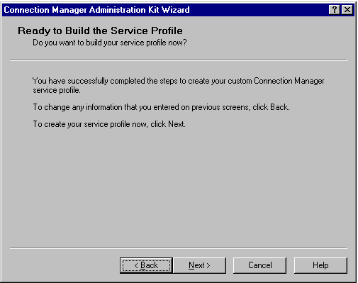
You create a service profile in three overall steps:
- Start the CMAK wizard.
- Run the CMAK wizard and enter all the necessary information.
- Let the CMAK wizard build your customized service profile.
Once the package has been generated, it will be automatically added to the Internet Explorer custom package. The package will be saved to c:\program files\cmak\profiles\<profile name>.

Appendix C: Creating a Pilot Program
Following are the steps necessary to create a pilot program. These are intended to be guidelines, as every environment is unique.
It also makes good practice to prepare a test plan and checklists for lab tests, and then use the test checklists to record satisfactory completion of tasks and note all problems with the process. Also, prepare a checklist to test each deployment and distribution strategy.

Step #1: Become Familiar with Tools

Prepare custom packages for deployment:
- Install and run the Internet Explorer Administration Kit 5 (Internet Explorer Administration Kit) Configuration wizard.
- Build custom packages containing the distribution files.
- Configure browser automatic-configuration files (.ins, .js, .pac).
- Configure download sites and install the distribution files.
- Copy distribution files to compact discs and floppy disks.

Deploy custom package to lab clients:
- Run Internet Explorer 5 Setup to install the custom package on each client.
- Install using each available user install option.

Operate lab client software after custom package is installed:
- Run Active Desktop™ to test all desktop features.
- Run Internet Explorer to test all add-ins and features.
- Run business applications to check for satisfactory operation.

Restore lab clients to their original state:
- Uninstall Internet Explorer 5 and add-ins.
- Verify that Internet Explorer components have been removed.
- Test the desktop and business applications.
Administrators should prepare a test lab and then test the proposed deployment strategies on lab computers that represent typical client/server configurations for the organization. If an organization is large or has groups with vastly different computing environments or needs, administrators may need to prepare multiple test labs and conduct tests at multiple sites.

Step #2: Prepare the Lab
Set aside a physical space for each lab and acquire a mix of computers that accurately reflects the organization’s hardware and software computing environment. If the organization uses portable computers that dial in from remote locations, or if additional servers or mainframe computers for business data are needed, give the lab computers an analog phone line and appropriate access to the network.
Configure lab clients and servers to represent typical business and user configurations for the organization. Be sure to include all operating system and business application configurations, as well as Internet and browser configurations. In addition, be sure to document the lab setup and maintain a record of any changes made to the setup.

Conduct the Tests
To test the deployment in the lab:
- Perform all deployment tasks using the test plan checklists.
- Identify problems with the deployment process and migration issues.
- Revise the deployment plan based on test feedback.
Maintain a record of all issues and problems encountered. These records will help when designing solutions to correct the problems. Be sure to follow the testing process described in this section when testing the solutions.
Before deploying Internet Explorer 5 to the organization, plan a pilot program to further test and refine deployment strategies and configurations. The pilot program is a scaled-down version of the full deployment using pilot groups that are representative of the users in the organization. To plan the pilot program:
- Select appropriate pilot groups.
- Document resources and tasks needed for the pilot program.
- Develop a user-support plan.
- Develop a user-training plan.

Step #3: Prepare the Pilot Program

Select Pilot Groups
Identify and select pilot groups, and prepare them for the pilot program. If the organization is large, or has groups with vastly different computing environments or needs, several pilot groups may be needed. Locate groups that are representative of the users in the organization. Make sure volunteers have enough time in their schedules and are willing to cooperate in the pilot program.

Document Resources and Tasks
Identify the tasks and resources necessary to conduct the pilot program, and add them to the project plan. Be sure to budget resources for the pilot program.

Develop the User Support Plan
Develop a user-support plan that meets the needs of the users. Identify the support staff and resources necessary, and then budget to make sure those support staff and resources are available for the pilot program. User support may include providing online support for deployment through a Web page on the administrator’s intranet, as well as providing support through the administrator’s Help desk.
This pilot user-support plan is the basis for the final deployment. Administrators should revise the plan based on feedback from the pilot program and use it to support users during the final deployment.

Develop the User Training Plan
Administrators should develop a training plan that meets user needs. Identify the training staff and resources necessary, and then make sure the staff and resources are available for the pilot program. User training may include Internet Explorer instruction on the administrator’s intranet and group preparation.
This training plan is the basis for the final deployment user-training plan. Administrators should revise the plan based on feedback from the pilot program and use it to train users for the final deployment.
The administrator can conduct the pilot program by preparing the pilot groups and then implementing the pilot program plan.

Prepare Pilot Groups
Announce the pilot program well in advance of the start date and follow up the announcement with several reminders. Conduct meetings with the pilot group managers and with the entire group to set their expectations and to answer any questions they have. Provide a presentation that explains how users will install Internet Explorer 5. Identify installation options available and explain where users can go for support.
Conduct training on the new features of Internet Explorer 5. Use e-mail to broadcast information about training conducting on your intranet. Be sure to explain how users can benefit from visiting the training page.

Step #4: Implement the Pilot Program Plan
To implement the pilot program plan:
- Prepare custom packages for deployment.
- Deploy custom packages to pilot users.
- Monitor and support users as they install Internet Explorer.

Prepare Custom Packages
To prepare the custom packages:
- Install Internet Explorer 5 on the production computer.
- Install the Internet Explorer Administration Kit on the production computer.
- Run the Internet Explorer Administration Kit Customization wizard as Corporate Administrator.
- Build the required custom packages.
- Configure download sites and install the distribution files.
- Copy distribution files to compact discs and floppy disks (if necessary).

Deploy Custom Packages
Use the appropriate distribution methods to deploy the custom packages of Internet Explorer 5 to pilot users. For example, the administrator can send e-mail messages to users that tell them how to download the custom package. Alternately, the administrator can attach batch files to the e-mail messages and instruct users to double-click the batch file to install the custom package. If the custom packages are being distributed on compact discs or floppy disks, distribute them to the users and provide e-mail instructions on custom package installation.

Monitor and Support Users
The user support team can monitor the progress of the pilot program and provide user assistance as necessary. Be sure to document all user trouble calls and problems as well as the staff resources required to support users during the pilot program. The administrator should use his/her experience during the pilot program to plan for the resources needed to support the final deployment.
Use the finalized deployment plan to deploy Internet Explorer 5 browser software to the rest of the organization. To finalize the deployment plan:
- Obtain feedback from all participants in the pilot, including users.
- Document lessons learned during the pilot program.
- Incorporate lessons learned and participant feedback into the deployment project plan.

Step 5: After the Pilot Program
After the pilot program is completed, administrators will most likely take the lessons learned and use them to update the Internet Explorer package. At the least, these changes will need to be validated in the lab. If any major changes are made, the administrator may decide to re-pilot the latest version. This iterative process of Planning→Developing→Testing can occur several times before a deployment is final.

Appendix D: Automatic Connections
Automatic Connections can be configured on a user’s workstation to automate the remote connection process. The ability to include a pre-configured dial-up connection to the administrator’s RAS server significantly reduces the overhead associated with supporting these connections. There are two different ways to create an automatic dial-up connection with the Internet Explorer 5 package: importing dial-up connections from the Internet Explorer Administration Kit workstation, or using the Connection Manager Administration Kit (CMAK). Each approach has advantages and disadvantages. This appendix is intended as a discussion of the merits and ramifications of each approach. Technical specifics can be found in the Internet Explorer Administration Kit Help file, Appendix D, and the Customization wizard walkthrough.

Importing a Connection
The easiest way to set up an automatic connection is to create the corporate RAS settings on the Internet Explorer Administration Kit workstation and then import the connection settings during the Customization wizard. Importing a connection will create a Dial-Up Networking (DUN) entry on each user workstation to match those on the Internet Explorer Administration Kit workstation. Dial-up, protocol, and proxy settings for each connection will also be imported. If more than one DUN entry is imported, the default connection on the Internet Explorer Administration Kit workstation will also be made the default on the user workstation. The primary advantage to this approach is that it is simple. DUN entries are usually familiar to both users and support technicians, which helps to reduce both the learning curve and administrative overhead. Imported DUN entries can be used in conjunction with a user’s existing DUN entries, such as a personal ISP.
Dial-Up Networking Entries work well in situations where a Dial-Up Point of Presence (such as a RAS server) have a single dial-up number to dial that is not likely to change. There are two situations in which using a CMAK profile will be a better solution:
- One disadvantage of importing existing connections is the static nature of a DUN entry. If users require more than a few dial-up numbers or an organization’s RAS numbers tend to change often, then the administrator is required to import a prohibitive number of separate DUN entries. When remote users need to connect to multiple numbers or when a package is going to be distributed to multiple groups of users with their own regional RAS numbers, the CMAK would be a better approach.
- Dial-up Networking profiles do not support connect actions. If the administrator wants to configure an application to run automatically before, during, or after a connection, then Connection Manager should be used.

The Connection Manager Administration Kit (CMAK)
The CMAK is used to create and administer Connection Profiles for Microsoft Connection Manager. Connection Manager is a client application similar to Dial-up Networking that supports: multiple phone numbers per Connection Manager profile, the ability to run applications automatically before, during, and after a connection occurs; and Virtual Private Networks. Connection Manager is part of Internet Connection Point Services for RAS, which is in the Windows NT 4.0 Option Pack. Connection Manager can be integrated with Connection Point Services for NT, which consists of a phone book administrator and a phone book service that can be used to automatically configure, administer, and dynamically update connection numbers to a client Connection Manager profile.
There are four major advantages to creating automatic connections with the CMAK. The first is support for multiple phone numbers per connection profile, a desirable option for organizations that have numerous RAS sites to which the users need to connect. Administrators can also dynamically update the Connection Manager phone book by using Connection Point Services. This feature is especially useful for organizations that need to constantly update a pool of dial-up numbers. A Connection Manager profile can also automatically run applications before, during, or after a connection is made. Finally, a Connection Manager profile can be configured with custom bitmaps and license agreements, Help files, user documentation, and command-line parameters.
The primary disadvantage of the CMAK is the added complexity of correctly configuring a Connection Manager Profile. Although static phone book entries can be used, Microsoft Connection Point Services are required to administer multiple phone book entries. Connection Manager profiles are different from DUN entries, and will require both users and administrators to learn how to use them. The use of auto-applications and connect actions can be useful to an organization, but increase the possibility of tech support calls if they don’t work as the user expects, or cause an application conflict (such as multiple e-mail clients running at the same time). If, however, an organization is already using both Connection Manager and Connection Point Services, then a CMAK profile can be integrated into an Internet Explorer package with a minimum of administrative overhead. Detailed information on the CMAK can be found in Appendix B, and in the CMAK documentation.

Appendix E: Using Microsoft Systems Management Server
One of the ways administrators can deploy customized Internet Explorer 5 packages is by using Microsoft Systems Management Server. Custom packages are still creating using the IEAK, but rather than point users to the new packages, Systems Management Server delivers the new package directly to their desktops. Systems Management Server provides many additional capabilities. For more information, please visit www.microsoft.com/smsmgmt.

Installing Internet Explorer 5 on Windows NT Workstation 4.0 systems without user administrative privileges
Administrators using Systems Management Server need to have special consideration when installing Internet Explorer 5 packages on Windows NT Workstation 4.0-based PCs without local user administrative privileges. Windows NT Workstation 4.0 is designed to reduce total cost of ownership. One of the ways Windows NT Workstation 4.0 demonstrates lower cost of ownership is by requiring users to have administrative rights to install applications. Many corporations do not provide users with administrative rights, which keeps users from installing untested and unauthorized applications.
Systems Management Server provides administrators with the ability to distribute applications to systems without local user administrative rights. However, Internet Explorer Setup requires Administrator rights to complete its installation on computers running Windows NT. The Systems Management Server Package Command Manager (PCM) service can deliver the first phase of the Internet Explorer installation and restart the client. The problem is that after the client is restarted, Internet Explorer Setup continues running instructions from the RunOnce section of the registry. The processes running from the registry require Administrator rights to complete the installation.
The following section provides guidelines for distributing Internet Explorer 5 using Systems Management Server on Windows NT Workstation 4.0 systems without user administrative privileges.

Using Systems Management Server 2.0
The purpose of this document is to provide a step by step walk through of how to go about not only successfully creating a package for deployment with SMS, but also serves as a guideline of what steps need to be taken to deploy this package to your Windows NT client machines. This is not meant to be an in depth guide to using Systems Management Server 2.0. This is meant to be a guide to assist corporate administrators to understand how to use the auto logon script and how to deploy their package onto client computers on their LAN. Also, this is just one setup scenario using Systems Management Server 2.0. There are other ways to achieve setup with Systems Management Server 2.0. For these other ways, please refer to Systems Management Server help documentation.
Before beginning, you should obtain and run the Iesms.exe file. This file contains the Iesetup.ipf and Shutdown.exe files. The following file is available for download from the Microsoft Software Library:
http://support.microsoft.com/download/support/mslfiles/Iesms.exe
For additional information about downloading files from the Microsoft Software Library, please see the following article in the Microsoft Knowledge Base:
Q119591 How to Obtain Microsoft Support Files from Online Services

STEP 1 - SETTING UP THE SERVER:
The set up of the server for Systems Management Server 2.0 differs quite a bit in the User Interface rather than in functionality. Most of the setup is done through the MMC (Microsoft Management Console). The following tasks are to be performed on the server that you have Systems Management Server installed on.
- Click Start/Programs/System Management Server/SMS Administrator Console. This will bring up the MMC.
- In the left-hand pane, you will need to expand the Site Database tree. Then expand the ‘Site Hierarchy’ under the Site Database.
- Right click on the site that comes up and choose Properties.
- Click on the Accounts tab. Here you will need to add an account. To do this, you will click the Set button. Put the user name for the Systems Management Server client remote installation account. The account needs to have domain admin rights). Now enter the password and then confirm password.
- Click OK.
- Click OK again.
- Navigate to the Systems Management Server Database/Site Hierarchy/<name of your site>/Site Settings/Client Agents. In the right hand pane you will see Advertised Programs Client Agent, right click on it. Select Properties. Place a check mark in the Enable Software Distribution to Clients check box. Here you may want to change the polling interval (time in which the client checks to see if there is a package awaiting deployment) by adjusting the Check for new programs every xx minutes.
- When done, click OK.
- Under Systems Management Server Database/Site Hierarchy/<name of your site>/Site Settings/Client Installation Methods, right click on Windows Networking Logon Client Installation in the right hand pane.
- On the General tab, Put a check in the checkbox labeled Enable Windows Networking Logon Client installation.
- Make sure that your domain is listed in the logon points box. If it’s not, then click on the gold star in the upper right hand and enter your domain.
- Go to the Logon Settings tab, put a check in the checkbox labeled Modify User Logon Scripts.
- Click OK.
- Under Systems Management Server Database/Site Hierarchy/<name of your site>/Site Settings/Discovery Methods, right click on Windows Networking Logon Discovery.
- Put a check in the Windows Networking Logon Discovery checkbox. Again, make sure that your domain is showing up here, if not, then add it by clicking on the gold star in the upper right hand and entering your domain.
- Make sure that the modify user logon scripts is still checked. If not, check it.
- Click OK.

STEP 2 – CUSTOMIZING AND COMPILING THE SCRIPT:
The following steps will go through customizing the Systems Management Server installer script, ‘iesetup.ipf’ and creating the iesetup.exe. The iesetup.exe file is generated when the iesetup.ipf script is compiled by Systems Management Server Installer You will need to have the Systems Management Server installer installed. Unlike 1.2, the Systems Management Server installer is now a part of the Systems Management Server installation. If you compiled your script with the older version of the Systems Management Server installer need to recompile your script using the Systems Management Server installer at least later than 2.0.64.00 or later.
The Iesetup.ipf is a sample script that modifies the client registry to enable automatic logon on the Windows NT clients with an Administrator account. For additional information about enabling automatic logon, please see the following article in the Microsoft Knowledge Base:
Q97597 How to Enable Automatic Logon in Windows NT
Administrators should follow these steps:
- Open the script ‘iesetup.ipf’ with in the Systems Management Server installer.
- Scroll down until you see the *SET DOMAIN ADMIN ACCOUNT NAME HERE* and change the variable to be the name of the account with domain admin rights.
- Directly below that, change the *SET DOMAIN ADMIN'S ACCOUNT PASSWORD* to the password for the domain admin.
- Directly below that, *SET DOMAIN NAME HERE*, change the value to the name of the domain of which the admin account is a part of.
- Save the file.
- On the Systems Management Server installer menu bar, click Installation/Compile. That will create an .EXE file with the same name as the installer script that you are using. In this case it is iesetup.exe. You’ll need to put the iesetup.exe and shutdown.exe into the same directory as the IE 5 installation files.
There are some factors that need to be addressed at this point. If you have created you IEAK package to be installed silently, you will not have to do any additional configurations to the script. The script has the syntax needed for a silent installation (ie: ie5setup.exe /Q:A /C:"ie5wzd /S:""#E"" /Q /R:N") All you will have to do is to remember to check the “Install Silently” check box in the IEAK when creating your customized installation of Internet Explorer.
But if you choose not to have the package install silently, and wish to have a user interface, you will need to make sure you do not check the “Install Silently” checkbox in the IEAK, plus you will need to go to the section of the script that looks like → Text=Executing %IENT_PATH%\ie5setup.exe /Q:A /C:"ie5wzd /S:""#E"" /Q /R:N", and remove the command line syntax. The line should read→ Text=Executing %IENT_PATH%\ie5setup.exe .
Here is a list of the switches that you can use to control Internet Explorer Setup:
- /Q - Specifies a quiet "hands-free" mode. The user is prompted for information that isn't specified.
- /B:iebatch.txt - Specifies the batch script file to use.
- /Q:A - Specifies a quiet mode with no user prompts.
- /Q:C - Specifies a quiet mode with the Cancel button not displayed, so the user cannot cancel Setup. The Internet Explorer Customization wizard uses this switch if you select the Install package silently option when you are installing as a corporate administrator.
- /M:[0|1|2|3...] - Specifies the installation mode. For customized IEAK packages, 0 refers to the first installation choice, 1 refers to the second choice, and so on (for example, 0=minimal, 1=typical (default), 2=full).
- /E:ComponentID,ComponentID - Specifies extra components to be installed regardless of the installation mode. Use this switch to specify components that aren't a part of the installation type you specified in the Customization wizard. This switch also overrides settings in the batch text file, if used. The ComponentID is a string that uniquely identifies a component; you can find the corresponding string in the component sections of the Iesetup.cif file.
- /S:""#e"" - Designates the source path of Ie5setup.exe. The ""#e"" refers to the full path and name of the .exe file. Note that the path must be surrounded by two pairs of double quotation marks.
- /R:N - Suppresses restarting the computer after installation. If you suppress restarting, your program should take care of restarting the computer. Internet Explorer is not configured correctly until the computer is restarted.
- /D - Specifies that you want to download only the files for the current operating system.
- /D:1 - Specifies that you want to download files for Microsoft Windows and Windows NT operating systems.
- /G: - Runs specified installation sections in Iesetup.inf. Separate sections with commas.
- /X - Installs Internet Explorer without the shell, icons, or links. This option is useful for hosting browser controls in your own application.
- /X:1 - Installs Internet Explorer with the shell, icons, or links, but does not take over default browser or http protocol associations.
- /P - Reports the required component and disk space cost for an installation. It enables you to see how much disk space will be used based on the installation options selected.
- /F -(Fix) Reinstalls all items on the user's computer that are the same version or newer. Using the /F switch ensures that no component is replaced with an earlier version.

STEP 3 – CREATING THE SYSTEMS MANAGEMENT SERVER PACKAGE:
The following will go through the steps needed to create your Systems Management Server package for deployment. This is not to be confused with the package you created of Internet Explorer that you created with the IEAK. This is the actual package that Systems Management Server will have scheduled as a job for distribution.
- In the MMC right click on Packages and click New/Package.
- On the General tab, give your package a name.
- Go to the Data Source tab, and put a check in the box in This Package Contains Source Files checkbox.
- Now click on the Set button
- Under the Source Version/Source Directory enter the path to the set up files in the source directory.
- Click OK.
- Go to Distribution Settings, and change the Sending Priority to high.
- Click OK. You’ll see the package under the Packages section.
- Expand your package under Packages.
- Right click on Distribution points and choose New/Distribution Points and follow the step in the wizard.
- Click next in wizard.
- Put a check in the check box on the server you want to use and click finish.
- Right click on Programs.
- Click on New/ Program, in the General tab give it a name.
- On the Command Line field, enter the full path to the script executable.
- Go to the Environment tab, clear the User Input Required check box.
- Put a check in the check box that is labeled Run with Administrative rights. *This is VERY important that this is done.
- Click OK.
You will now be brought back to the Packages window. Here you will now see your newly created Systems Management Server package.

STEP 4 – CREATING THE ADVERTISEMENT (JOB):
You will now create the job that will be scheduled for distribution.
- Go to Queries /All client systems.
- Right click on the client that you are wanting to install the package onto.
- Choose All Tasks/Distribute software. This will bring up the Distribute Software wizard.
- Click Next.
- Select your package.
- Click Next.
- Make sure your distribution site is selected, and click next.
- Select the program that you want to install.
- Click Next.
- On the Advertisement Target screen, choose the radio button labeled Create a New Collection Containing This Resource and Advertise To The New Collection.
- Click Next until you get to the Assign Program screen.
- Once at the Assign Program screen, Click Yes to assign the program.
- Click Next.
- Click Finish.
When your client shows up in the Queries/All clients systems then it’s ready to receive packages. The user will have to log on to the client machine before the server will recognize the client. This can be any account with user level rights.

STEP 5 – THE INSTALLATION PROCESS:
Now both the Systems Management Server and the client are in a ready state for installation. Once the client recognizes that there is a job pending, it will start the installation process. Here is what is happening during this installation process.
Phase 1:
Iesetup.exe performs the following tasks:
- Modifies the registry to enable automatic logon.
- Disables the keyboard and mouse services.
- Records the path to the Systems Management Server distribution server.
- Where the script is being executed from.
- Calls Shutdown.exe to restart the client computer.
Phase 2:
- The client restarts with automatic logon enabled, and with the keyboard and the mouse disabled. At this point, everything will be running under the context of the Administrator account.
- Ie5setup.exe runs from the registry. It starts Internet Explorer Setup in "quiet” mode.
- Internet Explorer Setup finishes the first phase of its installation.
- Iesetup.exe calls Shutdown.exe to restart the client computer.
Phase 3:
- Iesetup.exe starts again. It disables automatic logon, removes the Administrator account and password from the registry, and enables the keyboard and mouse services.
- Internet Explorer Setup continues with the final phase of the installation. Iesetup.exe calls shutdwon.exe with a 30 seconds timer. You may need to adjust the timer to allow sufficient time for Microsoft Internet Explorer to finish its configuration. At this point, Internet Explorer is completely installed, but it must configure itself for the Administrator account that is running these procedures.
- The client is restarted and is ready for the user to log on.

Using Systems Management Server 1.2
This section describes a procedure to deploy Internet Explorer 5 through Microsoft Systems Management Server 1.2 to Microsoft Windows NT Workstation-based PCs when the user is not an administrator on the local computer. It provides a walk through of how to go about not only successfully creating a package for deployment with SMS, but also serves as a guideline of what steps need to be taken to deploy this package to your Windows NT client machines. It is not meant to be an in depth guide to using Systems Management Server 1.2. This is meant to be a guide to assist corporate administrators to understand how to use the auto logon script and how to deploy their package onto client computers on their LAN. Also, this is just one setup scenario using Systems Management Server 1.2. There are other ways to achieve setup with Systems Management Server 1.2. For these other ways, please refer to Systems Management Server help documentation.
Before beginning, you should obtain and run the Iesms.exe file. This file contains the Iesetup.ipf and Shutdown.exe files. The following file is available for download from the Microsoft Software Library:
http://support.microsoft.com/download/support/mslfiles/Iesms.exe
For additional information about downloading files from the Microsoft Software Library, please see the following article in the Microsoft Knowledge Base:
Q119591 How to Obtain Microsoft Support Files from Online Services
The procedures described below require that the Windows NT clients run the Systems Management Server Package Command Manager as a service.
The PCM service requires a user account that has:
- Domain Administrator privileges on the client computer.
- Domain user authority to read PCM instruction file on the Systems Management Server logon server and run a setup program in the package directory on the Systems Management Server distribution server.
Because it works through a user account with administrative privileges, the PCM service can perform tasks that the PCM application cannot. For example, it can install files into secured directories or make changes to secured registry keys. For additional information about installing the Package Command Manager service, please see the following article in the Microsoft Knowledge Base:
Q167114 SMS: PCM Service Now Available for Windows NT Clients

STEP 1 - SETTING CLIENT UP WITH PACKAGE COMMAND MANAGER:
Make sure that the client machine is in the same domain as the Systems Management Server. If not, there are other issues that need to be resolved (ie: authentication issues, etc). For further information on this issue, please refer to your Systems Management Server help documentation.
- Run runsms.bat in the profile that will be active during installation. Runsms.bat should be installed by connecting to the Systems Management Server through a UNC path, ie: \\<sms server>\sms_shrc\login.srv\runsms.bat
- Reboot the client machine
- Run rservice.exe with your customized .ini file on client to install Package Command Manager as a service. This must be done on the client while logged in as the domain administrator. Start/Run/Cmd. At the command prompt, type c:\rservice.exe rservice.ini /install
- Reboot the client machine
- Log back into the client. At this point not only has the Package Command Manager been installed and started as a service on the client machine, it is also telling the Systems Management Server that it is an Systems Management Server client.

STEP 2 – CUSTOMIZING AND COMPILING THE SCRIPT:
The following steps will go through customizing the Systems Management Server installer script, ‘iesetup.ipf’. and creating the iesetup.exe. The iesetup.exe file is generated when the iesetup.ipf script is compiled by Systems Management Server Installer You will need to have the Systems Management Server installer installed on the Systems Management Server server.
The Iesetup.ipf is a sample script that modifies the client registry to enable automatic logon on the Windows NT clients with an Administrator account.
For additional information about enabling automatic logon, please see the following article in the Microsoft Knowledge Base:
Q97597 How to Enable Automatic Logon in Windows NT
Administrators should take the following steps:
- Open the script ‘iesetup.ipf’ with in the Systems Management Server installer.
- Scroll down until you see the *SET DOMAIN ADMIN ACCOUNT NAME HERE* and change the variable to be the name of the account with domain admin rights.
- Directly below that, change the *SET DOMAIN ADMIN'S ACCOUNT PASSWORD* to the password for the domain admin.
- Directly below that, *SET DOMAIN NAME HERE*, change the value to the name of the domain of which the admin account is a part of.
- Save the file.
- On the Systems Management Server installer menu bar , click Installation/Compile. That will create an .EXE file with the same name as the installer script that you are using. In this case it is iesetup.exe. You’ll need to put the iesetup.exe and shutdown.exe into the same directory as the IE 5 installation files.
There are some factors that need to be addressed at this point. If you have created you IEAK package to be installed silently, you will not have to do any additional configurations to the script. The script has the syntax needed for a silent installation (ie: ie5setup.exe /Q:A /C:"ie5wzd /S:""#E"" /Q /R:N") All you will have to do is to remember to check the “Install Silently” check box in the IEAK when creating your customized installation of Internet Explorer.
But if you choose not to have the package install silently, and wish to have a user interface, you will need to make sure you do not check the “Install Silently” checkbox in the IEAK, plus you will need to go to the section of the script that looks like → Text=Executing %IENT_PATH%\ie5setup.exe /Q:A /C:"ie5wzd /S:""#E"" /Q /R:N", and remove the command line syntax. The line should read→ Text=Executing %IENT_PATH%\ie5setup.exe.
Here is a list of the switches that you can use to control Internet Explorer Setup:
- /Q - Specifies a quiet "hands-free" mode. The user is prompted for information that isn't specified.
- /B:iebatch.txt - Specifies the batch script file to use.
- /Q:A - Specifies a quiet mode with no user prompts.
- /Q:C - Specifies a quiet mode with the Cancel button not displayed, so the user cannot cancel Setup. The Internet Explorer Customization wizard uses this switch if you select the Install package silently option when you are installing as a corporate administrator.
- /M:[0|1|2|3...] - Specifies the installation mode. For customized IEAK packages, 0 refers to the first installation choice, 1 refers to the second choice, and so on (for example, 0=minimal, 1=typical (default), 2=full).
- /E:ComponentID,ComponentID - Specifies extra components to be installed regardless of the installation mode. Use this switch to specify components that aren't a part of the installation type you specified in the Customization wizard. This switch also overrides settings in the batch text file, if used. The ComponentID is a string that uniquely identifies a component; you can find the corresponding string in the component sections of the Iesetup.cif file.
- /S:""#e"" - Designates the source path of Ie5setup.exe. The ""#e"" refers to the full path and name of the .exe file. Note that the path must be surrounded by two pairs of double quotation marks.
- /R:N - Suppresses restarting the computer after installation. If you suppress restarting, your program should take care of restarting the computer. Internet Explorer is not configured correctly until the computer is restarted.
- /D - Specifies that you want to download only the files for the current operating system.
- /D:1 - Specifies that you want to download files for Microsoft Windows and Windows NT operating systems.
- /G: - Runs specified installation sections in Iesetup.inf. Separate sections with commas.
- /X - Installs Internet Explorer without the shell, icons, or links. This option is useful for hosting browser controls in your own application.
- /X:1 - Installs Internet Explorer with the shell, icons, or links, but does not take over default browser or http protocol associations.
- /P - Reports the required component and disk space cost for an installation. It enables you to see how much disk space will be used based on the installation options selected.
- /F -(Fix) Reinstalls all items on the user's computer that are the same version or newer. Using the /F switch ensures that no component is replaced with an earlier version.

STEP 3 – CREATING THE Systems Management Server PACKAGE:
The following will go through the steps needed to create your Systems Management Server package for deployment. This is not to be confused with the package you created of Internet Explorer that you created with the IEAK. This is the actual package that Systems Management Server will have scheduled as a job for distribution.
- You’ll create the package in the Systems Management Server administrator. On menu bar, click button labeled ‘Open Window: Packages’, you’ll see the ‘Packages’ window.
- Now, on the menu bar click File/New. You’ll see the ‘Package Properties Window’. *You can give any name and any comment you wish.
- Click on the Workstations button, in the source directory field, enter the UNC path to where you have the IEAK installation package residing (i.e.: \\server\share).
- Click on the Properties button, you can specify any command name you wish. Command Line is the location of the script file (\\server\share\iesetup.exe).
- You will also see two checkboxes here, one labeled ‘Automated Command Line’ and the other is ‘System (background task)’. Make sure both check boxes are checked.
- You will also see the box named ‘Supported Platforms’. Check the boxes to the platforms that you will be installing the IE package on. In this case, it’s Windows NT (x86).
- Click OK.
- Click Close.
- Click OK.
You will now be brought back to the Packages window. Here you will now see your newly created Systems Management Server package.

STEP 4 – CREATING THE JOB:
You will now create the job that will be scheduled for distribution.
- In the Systems Management Server administrator, click the button labeled ‘Open Window: Jobs’
- Also click the ‘Open Window: Sites” option.
- In the Sites windows, expand the tree to see your intended client (s).
- Drag the package from the Packages window and drop it onto your clients name in the Sites window. That will bring up the job details dialog box.
- Here you will see the ‘Distribute’ phase section with two checkboxes. One is called ‘Refresh Existing Distribution Servers’, and the other is called ‘Put On Specified Distribution Servers’, make sure that both of these are checked.
- In the drop down box, make sure it says ‘Default Servers’.
- In the Run Phase section, make sure that ‘Run Workstation Command’ is checked. *In the drop down box below that, you should see the name that you specified in the Command name field in the Package Properties window.
- Click on the check box that says ‘Mandatory After’, and ‘Offer After’ should be equal.
- Uncheck Expires after radio button.
- Click OK. *This will bring you back to the job properties box.
- Click on the button that says schedule, and change the priority to high.
- Click OK.
- Click OK.
In the jobs window you will see the job you just made. The status should say pending.
Now wait for the job to show active status in the job window. Once it does, the package will be available for installation, once your client acknowledges that the package is there.

STEP 5 – THE INSTALLATION PROCESS:
Now both the Systems Management Server and the client are in a ready state for installation. Once the client recognizes that there is a job pending, it will start the installation process. Here is what is happening during this installation process.
Phase 1:
Iesetup.exe performs the following tasks:
- Modifies the registry to enable automatic logon.
- Disables the keyboard and mouse services.
- Records the path to the Systems Management Server distribution server where the script is being executed.
- Calls Shutdown.exe to restart the client computer.

Phase 2:
- The client restarts with automatic logon enabled, and with the keyboard and he mouse disabled. At this point, everything will be running under the context of the Administrator account.
- Ie5setup.exe runs from the registry. It starts Internet Explorer Setup in "quiet” mode.
- Internet Explorer Setup finishes the first phase of its installation.
- Iesetup.exe calls Shutdown.exe to restart the client computer.

Phase 3:
- Iesetup.exe starts again. It disables automatic logon, removes the Administrator account and password from the registry, and enables the keyboard and mouse services.
- Internet Explorer Setup continues with the final phase of the installation. Iesetup.exe calls shutdwon.exe with a 30 seconds timer. You may need to adjust the timer to allow sufficient time for Microsoft Internet Explorer to finish its configuration. At this point, Internet Explorer is completely installed, but it must configure itself for the Administrator account that is running these procedures.
- The client is restarted and is ready for the user to log on.

Glossary of Terms
Active Desktop – One of the two components installed with Windows Desktop Update. Active Desktop allows users to add active content, such as a stock ticker, to their desktop, taskbar, or folders. Users can also single-click files to run and open them. Active Desktop can be disabled in the Internet Explorer Administration Kit, even if Windows Desktop Update is installed.
Authenticode – Authenticode lets a corporate administrator preconfigure security zones, preset ratings, and customize certification authorities. The administrator can also set system policies and restrictions to control whether users can modify their security settings.
Automatic Configuration – Automatic Configuration is a feature of Internet Explorer that allows the administrator to dynamically configure settings from the Internet Explorer Administration Kit, as well as system policies and restrictions.
AVS – Automatic Version Synchronization automatically checks for updated versions of each Internet Explorer Component every time the Internet Explorer Administration Kit is run. Updated components can be downloaded from Microsoft and included in subsequent Internet Explorer Administration Kit packages.
Bitmap – Bitmaps (.bmp) files are used for updating the graphics in an Internet Explorer Administration Kit package. Most common graphic formats can be simply saved as bitmaps by using the “Save As” command in Microsoft Paint.
Branding – Branding is the idea of customizing the Internet Explorer browser and components, the installation wizard, and CD Autorun screen with an organization’s artwork, text messages, welcome pages, etc. Branding an installation differentiates a corporate package from a generic Internet Explorer installation.
CD Autorun Screen – The CD Autorun screen is automatically displayed when an Internet Explorer installation CD is inserted into a workstation. The CD Autorun Screen typically consists of an “Install Internet Explorer 5” button, a “Cancel” button, and a customizable graphic.
Certification Authorities (CAs) – Certification Authorities are companies such as VeriSign or GTE that issue digital certificates. Certification Authorities provide a trusted source to verify the authenticity of a certificate.
Certificates – See Digital Certificates.
Channels and Categories - A channel is a Web site that has been enabled for information-receiving programs. The mechanism that makes this possible is the Channel Definition Format (.cdf) file. Channels can be organized into Categories and placed on the user’s desktop.
CMAK – The Connection Manager Administration Kit is a tool for creating, editing, and managing Connection Manager Profiles. The CMAK is included with the Internet Explorer Administration Kit.
Code Signing – Code signing is the process of signing a completed Internet Explorer package with a digital certificate. Signing the package requires two steps: obtaining a digital certificate and signing the code. Administrators do not need to sign files that are going to be installed on the UNIX or Windows 3.x platforms.
Component – The administrator can include many Internet components from Microsoft and other companies with the Internet Explorer browser. Examples of components are Outlook Express, Microsoft NetMeeting, and the VDOLive player.
Configuration Identifier – The Configuration Identifier is a string of text that allows a Web site to identify the types and versions of browsers.
Connection Manager Profile – Connection Manager Profiles are objects similar (but not the same as) Dial-Up Networking Entries. Connection Manager Profiles are one way of automating a dial-up connection.
Connection Settings – Connection Settings are the settings that Internet Explorer uses to connect to the Internet. Connection Settings are typically collections of settings for dial-up networking entries, such as proxy settings, account and passwords, and modem configurations.
Content Ratings - Microsoft Internet Explorer provides a way to help administrators control the types of content that the computer can access on the Internet. The administrator can adjust the settings to reflect what he/she thinks is appropriate content in the areas of language, nudity, sex, and violence.
Customization Wizard – The Customization wizard is one of the main components of the Internet Explorer Administration Kit. It is used to generate a customized version of Internet Explorer for installation in a specific organization.
Custom Package –A custom package contains customized versions of all of the installation tools, browser code, and additional components necessary to quickly and easily deploy Internet Explorer to the organization.
Deployment – Deployment is the actual process of installing Internet Explorer to an entire organization. A deployment should be contrasted with a “pilot,” which is the installation of Internet Explorer on a group of test users.
Desktop Update – See Windows Desktop Update.
Digital Certificates – Administrators should sign their code with a Digital Certificate if planning to distribute an Internet Explorer package over the Internet. Digital Certificates are issued by Certification Authorities, show where a program comes from, and prove that a package hasn’t been altered.
Favorites – Favorites are predefined links to Web sites. Favorites are also known as “bookmarks.” Favorites in Internet Explorer can be configured to automatically notify the user when content changes.
File Path – The File Path, in the context of a Web Deployment, is the actual local path to the distribution files on a Web server. A typical example might be “c:\inetpub\wwwroot\ie5\download.”
Folder Webviews - Administrators can customize how My Computer and Control Panel appear on a company's computers by customizing the HTTP files that serve as templates for them. Folder Webviews require Windows Desktop Update to be installed.
GUID - A globally unique identifier (GUID) is an identifier that distinguishes one program or object from another. When using the Internet Explorer Administration Kit, administrators can generate a GUID for each custom component that added.
Home Page – The Home Page is displayed every time Internet Explorer is started.
Internet Explorer Administration Kit – The Internet Explorer Administrator Kit (Internet Explorer Administration Kit) is the tool used to create, distribute, and manage customized Internet Explorer packages across an organization.
Infopane – See Outlook Express Infopane.
Keycode – The Keycode is a license code that is issued to an organization when it downloads the Internet Explorer Administration Kit. The Keycode is not required to install the Internet Explorer Administration Kit, but it is required to generate Internet Explorer Administration Kit packages.
Kiosk Mode Start Page – A Kiosk Mode Start Page can be specified for CD Installation. This page will appear in kiosk (full-screen) mode, in which the browser toolbar and menu bar are not displayed.
Lab – A Lab is a collection on non-production machines used to test an Internet Explorer Package. The Lab is not the same as a Pilot Group.
LDAP – The Windows Address Book supports LDAP (Lightweight Directory Access Protocol) for accessing directory services, and it comes with built-in access to several popular directory services. Administrators can specify an additional service for their users.
Media – Media refers to the physical methods used for package distribution. Typical media choices are CD-ROM, Web download, or floppy disk.
Newsgroups – See Usenet.
Outlook Express Infopane - The Outlook Express InfoPane is an area for content providers to place helpful information and links. Administrators can customize this pane with support numbers, frequently asked questions (FAQs), and information about the company.
Package – A Package is a set of customized installation code for Internet Explorer. A Package contains all necessary code and files to install, configure, and run Internet Explorer. The Internet Explorer Administration Kit can configure packages for several different types of installation media.
Pilot Group – A Pilot Group is a representative sample of production machines that are used to test an Internet Explorer package before a full deployment to the entire organization. A Pilot Group is different from a Lab in that it uses production machines and users.
Platform – A platform is a type of client, such as Windows 95, Windows 3.x, Macintosh, or UNIX.
Profile Manager – The Profile Manager is one of the major components of the Internet Explorer Administration Kit. The Profile Manager is used to create and dynamically manage browser and desktop automatic configuration settings.
Proxy – A proxy server provides network address translation and Web content caching services for Web browsers. Proxy settings can be configured automatically as part of an Internet Explorer Administration Kit package.
Realms – Realms are a feature of the CMAK that provide a prefix (such as company\) or suffix (such as @company.com) to a user name when connecting to a Connection Manager service.
Security Zones – The new Internet Explorer 5 security options enable administrators to assign specific Web sites to various security zones, depending on how much the administrator trusts the content of the Web site. Security Zones allow an administrator to restrict user access to certain Web sites.
Shell Integration – Shell Integration is one of the two components of Windows Desktop Update. Shell Integration lets users browse their computers just as they browse the Web. Users will find the Go and Favorites menus everywhere.
Titlebar Text – Titlebar text is the text at the top of a program window. The Titlebar text can be branded for several windows in and Internet Explorer package, including the CD Autorun screen, the Browser itself, and Outlook Express.
URL – Uniform Resource Locator. An URL is a Web address, such as “http://www.microsoft.com.”
Versioning – There are two types of Internet Explorer versioning: Each Internet Explorer package will be assigned a version number, and versioning can be enforced so that older packages are not allowed to overwrite newer versions of the same package. Individual components in Internet Explorer are also versioned, and configured not to download or install if a compatible version of the component already exists on the client machine.
Watermark – The Watermark is a bitmap that is displayed behind the Internet Explorer Toolbar. The Watermark should be colored so that it does not obscure the text or graphics of Toolbar buttons.
Web Path – In the context of a Web Deployment, the Web path is the path used to connect a browser to the Internet Explorer installation files. A typical Web Path for browser deployment might be “www.mycompany.com/ie5.”
Welcome Page – The Welcome page is only displayed the first time that Internet Explorer is run. Subsequently, the Home page is the page that is automatically displayed when Internet Explorer is started.
Windows Desktop Update – Windows Desktop Update consists of two components: Active Desktop and Shell Integration. Windows Desktop Update is included in Windows 98, and will not be reinstalled on machines with these operating systems.

# # #

Microsoft Systems Management Server provides comprehensive planning, deployment and diagnostic tools, including the ability to distribute Internet Explorer 5 packages (in conjunction with the Internet Explorer Administration Kit). Although this guide focuses on using the Internet Explorer Administration Kit to deploy Internet Explorer 5, the Appendix includes special considerations for using Systems Management Server to deploy Internet Explorer 5 on Windows NT® Workstation 4.0-based PCs, particularly when local users do not have administrative privileges. For more information on using Systems Management Server to deploy Internet Explorer 5, please visit www.microsoft.com/windows/ie. For general information about Systems Management Server, please visit www.microsoft.com/smsmgmt.
UNIX and 16-bit Windows capabilities may vary.
Required information only if distributing Internet Explorer 5 over an Intranet.
Microsoft provides a sample script is available on www.microsoft.com/windows/ie.
rservice.exe can be found on the SMS SP4 CD under support\PCMSVC32\X86 (or Alpha). Information on creating the customized .ini file can be found on the SMS SP4 CD under support\PCMSVC32\install.doc).
A sample script is available on www.microsoft.com/windows/ie.

